**31250- Introduction to Data Analytics**

**Assignment 3 – Data Mining in Action**

**Name – Khushbu Oswal**

**ID – 14098887**

**Data Mining Problem:**

This assignment is a practical data analytics project that follows on from the data exploration we did in an earlier assignment. The task requires us to make a prediction on a dataset as data scientists at a consultancy company. We need to predict the class attribute that is subscribed. We need to build a classifier that classifies the "subscribed" attribute, whether the client will subscribe to a term deposit or not.

For this project, data files are provided in three formats: the training dataset, the unknown dataset to be used for the testing phase, and the Kaggle submission sample to help us understand how to submit. Pre-processing of our data is carried out on the training dataset, which on validation, can be used to predict the class attribute. By looking at different methods and choosing the best parameters, a classifier that is as accurate as possible can be built. Once the model has been built, the unknown dataset will be used for prediction and verification.

This project report aims to explore the best methods to classify and predict the required attribute by identifying the best classifiers and methods by using multiple classifiers, pre-processing data, and testing different parameters and settings. The best model works on the unknown dataset to show the best accuracy and f-score.

**Data Pre-processing and Transformations:**

The following nodes were used for data pre-processing, exploration and transformations, and the screenshot of the nodes is below:

**Decision Tree:**

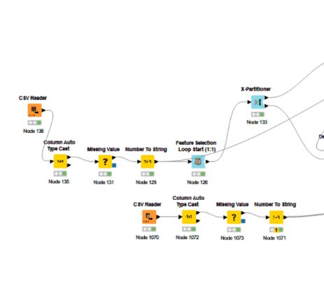

Figure1

**K Nearest Neighbour:**

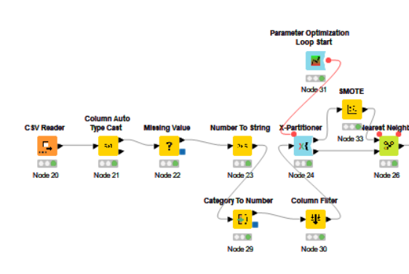

Figure2

**Random Forest:**

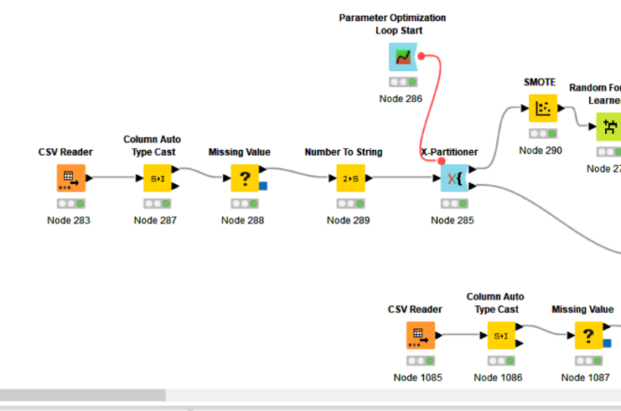

Figure3

**Tree Ensemble:**

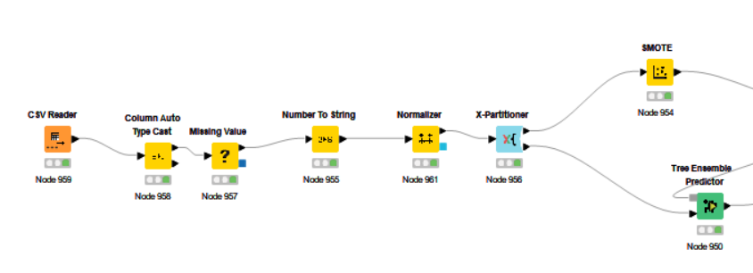

Figure4

**Gradient Boosted**

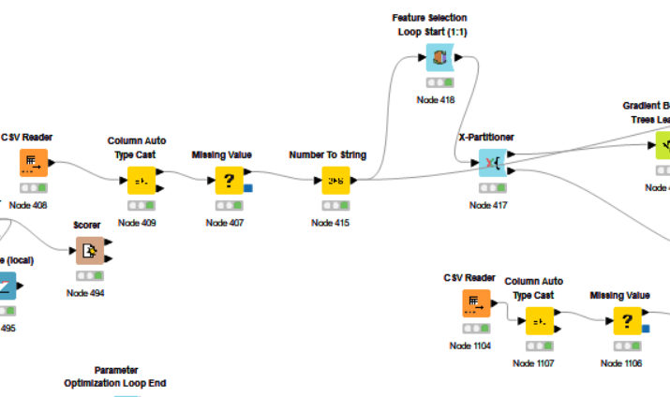

Figure5

**Neural Network:**

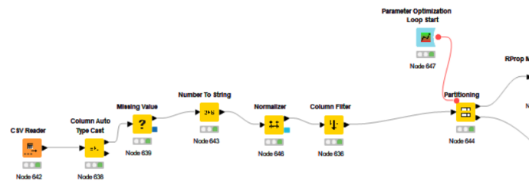

Figure6

**Support Vector Machine:**

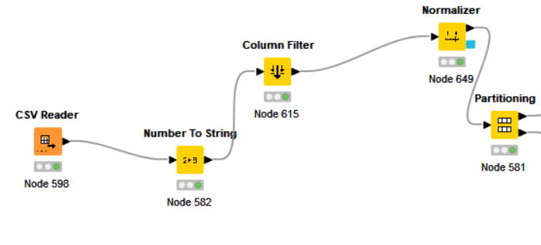

Figure7

**Probabilistic Neural Network:**

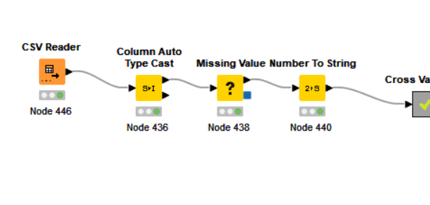

Figure8

**Naive Bayes and Fuzzy Rule:**

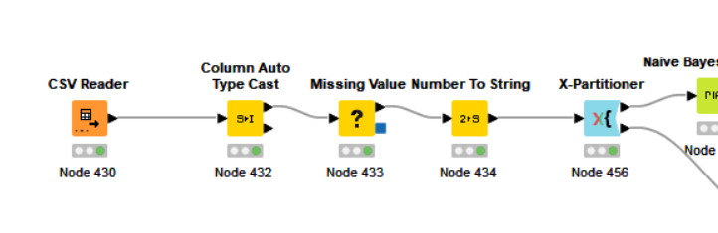

Figure9

1. **Column Filter**

It filters out unnecessary columns and moves ahead with the appropriate column to proceed with the data analysis. It does not affect the column attribute.

The following columns have been filtered out: Pdays, emp.var. rate, euribor3m by using the rank correlation. It shows the negative correlation between the column attribute and the above attributes. However, by using this method best accuracy was not obtained for the models.

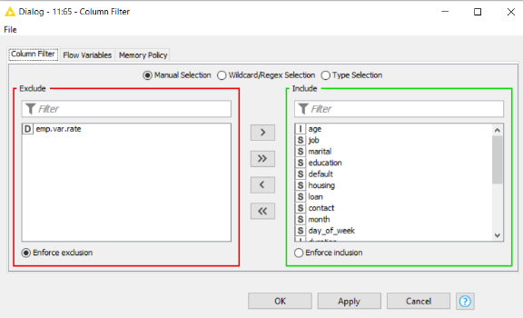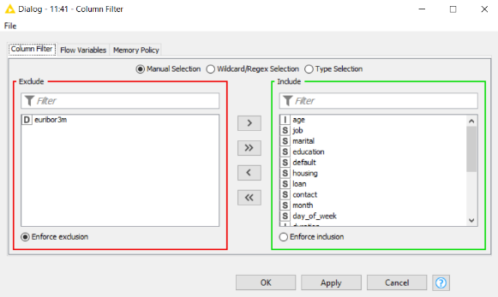

Figure10

So, the logic used to filter out the column was the split column of the random forest, which helped to filter out the non-required column. The columns filtered out are housing - housing loan, loan - personal loan and cons.conf.idx - consumer confidence index. Best accuracy was obtained by filtering out the above column in the random forest model 2nd model which is not consider.

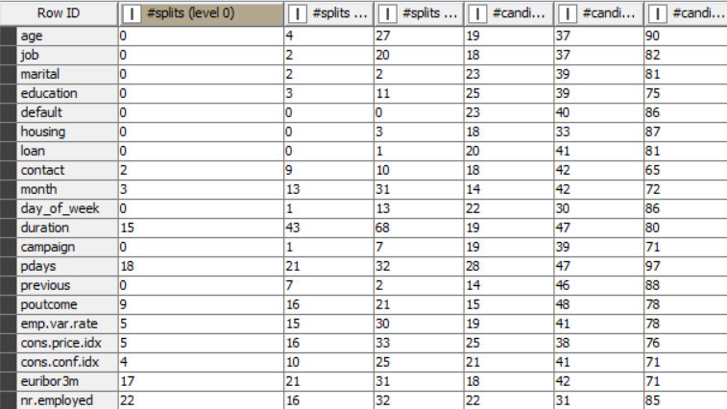

Figure11

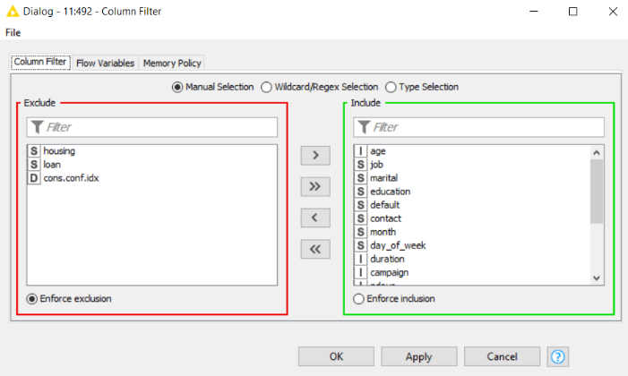

Figure12 Random Forest 2nd Model

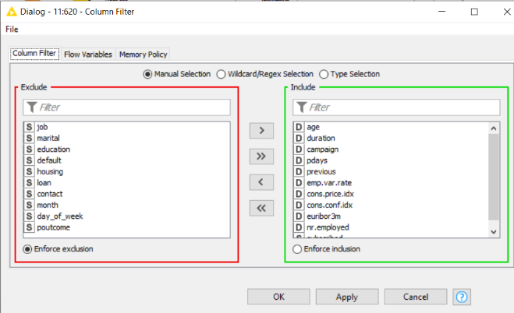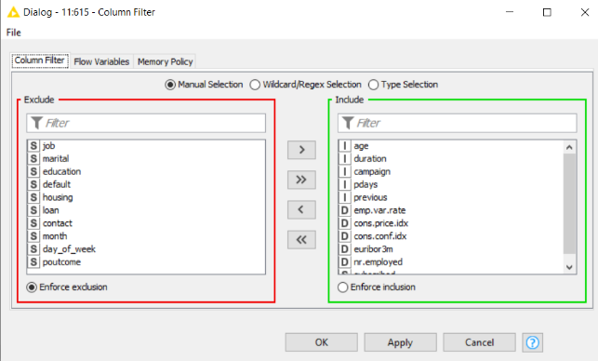

Figure13

In the K–nearest, Support vector machine and neural network different column filtering is used because it shows error that Input contains more than one non-numeric column, or the node will take only double values.

1. **Missing Value**

This node manages missing values in columns of the input table. The missing values are replaced by calculating the mean value of all non-missing cells in a column (Integer and double – mean). Calculating the most frequent value in a column replaces the missing values in a column (String – most frequent value). The pre-processing stage helped replace the missing value with the column's mean and most frequent value. Removing necessary columns with the help of the missing value column filter will bring inaccuracy. The most appropriate solution was, therefore, to replace missing values with other values.

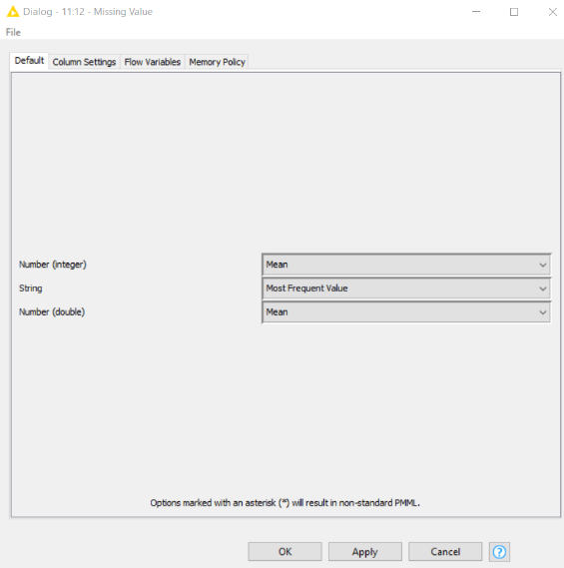 Figure14

**3. Column Auto Type Cast**

This node is used to determine the missing value pattern of the dataset. In addition, this node determines the most specific type in the configured string columns and changes the column types accordingly. Missing Value Pattern: The entered missing value pattern "unknown" is applied to all included columns.

QuickScan: Clicked this checkbox to speed up the node. Based on the 26,400 rows, the node determines the most specific type.

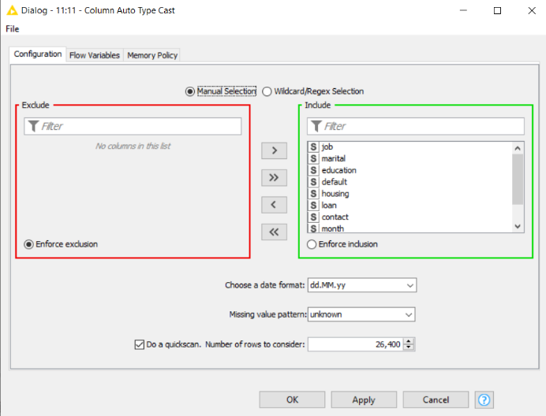Figure15

**4.Number to String**

This node was used to convert the attribute types. This node is used to convert numbers to strings. This was used to convert the integer column of the target attribute- subscribed to a string. Some classifiers only work with string types, not numeric values.

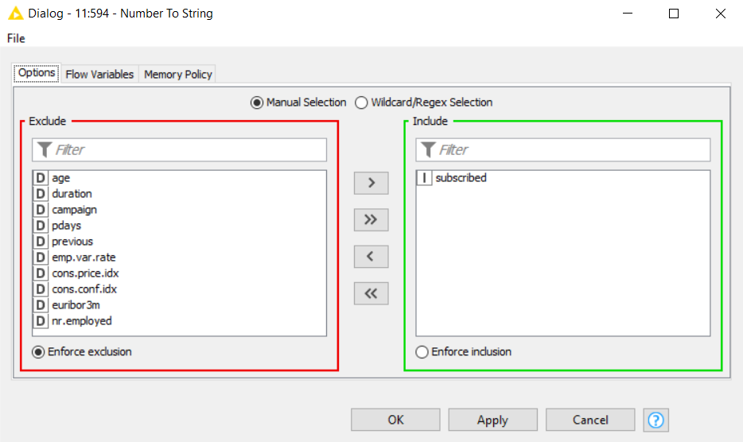Figure16

**5.Partitioning**

The purpose of this node is to divide the data into training and testing sets. In order to obtain the best accuracy and F measure, different ratios were tried and tested until the best value was selected. For example, cases of 80-20 and 60-40 were tried out, but most of the classifiers came up with solutions with the 70-30 partition. Partitioning is done randomly.

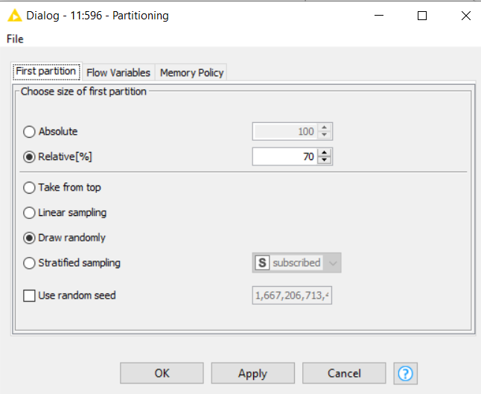Figure17

1. **SMOTE (Synthetic Minority Over-sampling Technique)**

This algorithm helps to overcome the overfitting problem generated by random oversampling of minority classes. It balances the data. It helps to give the model the best f- measure and accuracy. Based on the estimation between positive instances that lie together, it focuses on the feature space to generate new instances.

Figure18

**7.Normalizer**

The normalizer was used to normalize the attributes. In order to facilitate classification, this is primarily done to eliminate potential biases. In addition, normalizing the data generally speeds up the process and leads to faster results. Attempts were also tried out with the z-score normalization. However, min-max normalization showed the best results in terms of the f-score and accuracy. Therefore, Min-max normalization was conducted for this project.

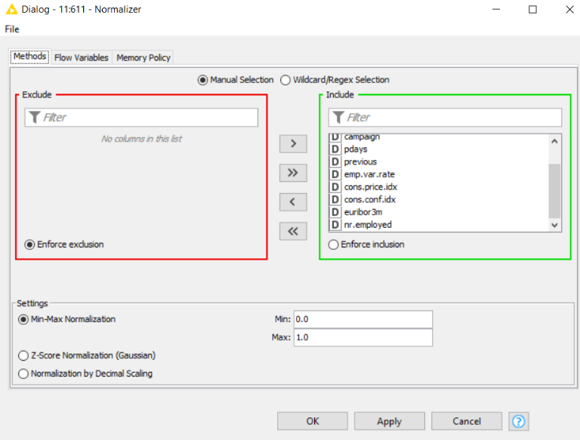Figure19

**8. Category to Number**

In this node, nominal columns are transformed into integers by mapping each category to an integer. Figure 7 is above. It changed every string column to number. The subscribed column was excluded because it was the class column. Category to Number was used in the K-nearest model as it shows an error that the input column contains more than one non-numeric column. It also increases the accuracy of the model. Other models were not able to perform well while using this node. Maximum categories, default value and increment is set as default values.

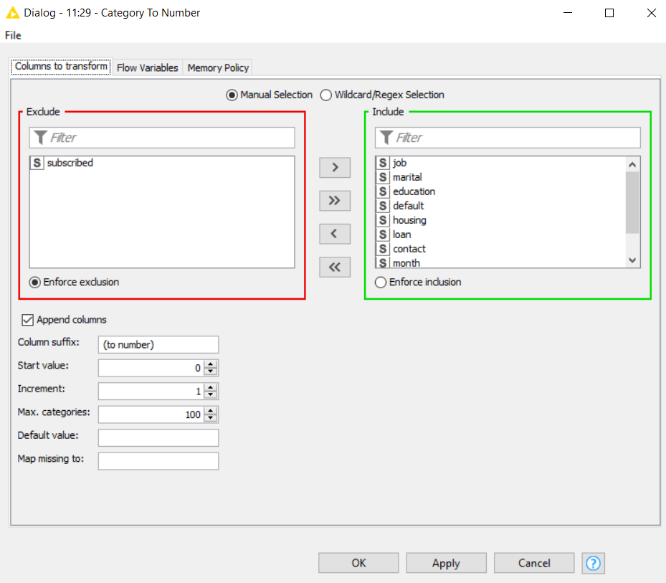

Figure20

**9. Rank Correlation**

Ranking correlations determine the degree of similarity between two attributes and can be used to evaluate their value. If one the variable decreases as the other increases, the rank correlation coefficients will be negative. If one the variable increases as the other increases, the rank correlation coefficients will be positive.

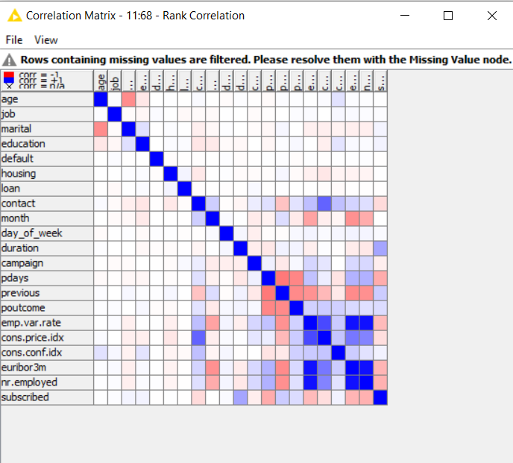Figure21

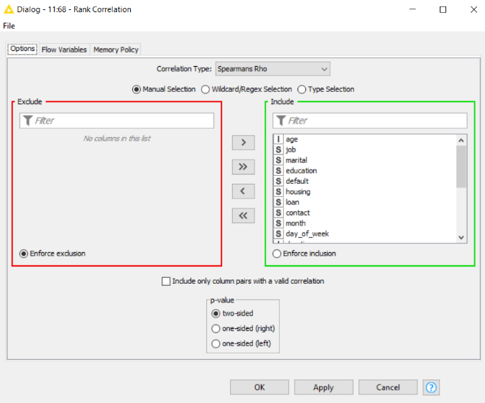Figure22

**10. K-fold method:**

**10.1**

**X-Partitioner Node and**

**X-Aggregator Node**

This process is known as K – fold cross-validation loop. In k-fold cross-validation, the original sample is partitioned into k equal sized subsamples. The x-partitioner node allows to set the number of cross validation iterations that should be performed. The default number of cross validation iterations that should be performed. At the end of the loop, an X-Aggregator must collect the results from each iteration. All nodes in between these two nodes are executed as many times as iterations should be performed. In X- the partitioner number of validations is chosen as ten because it has a large dataset.

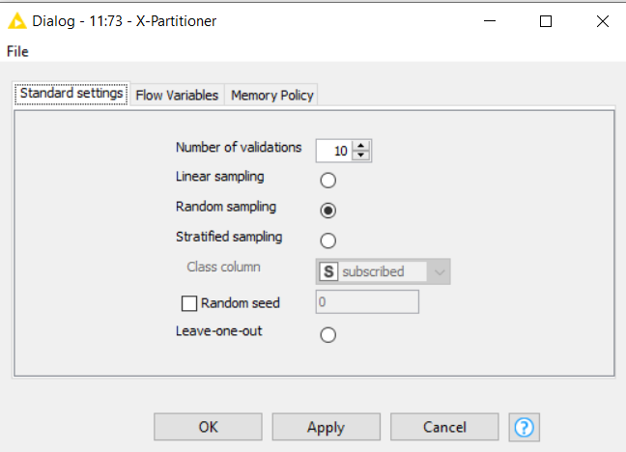Figure23

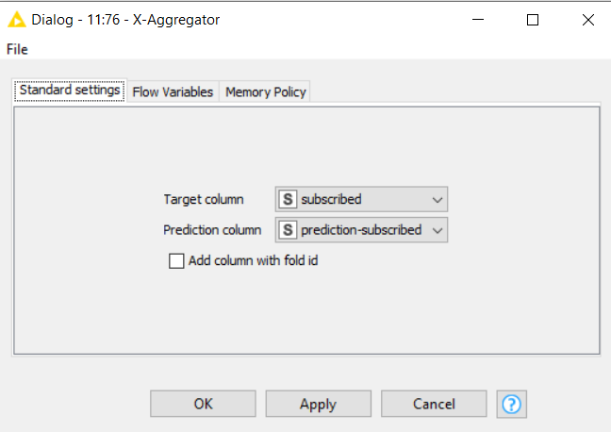Figure24

**10.2Cross Validation**

Cross validation is a meta node of the x-partitioner, x-aggregator and model.

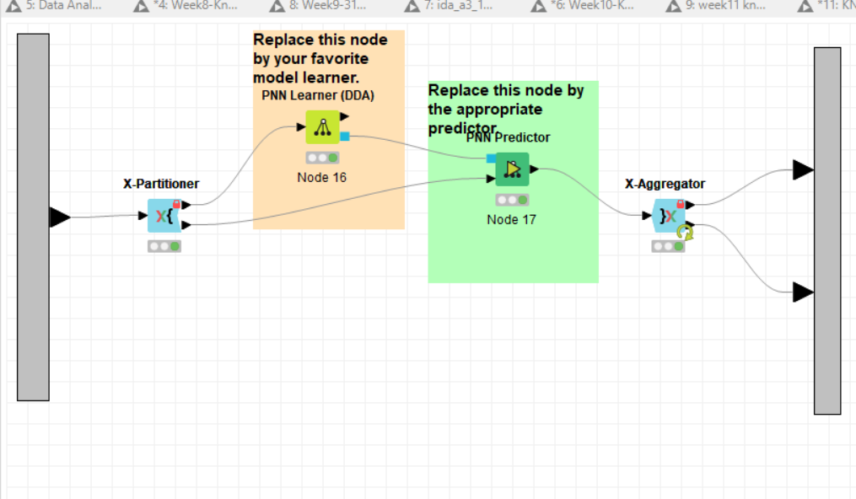Figure25

1. **Feature Selection:**

**Feature Selection Loop Start Node**

This node is the start of the feature selection loop. This loop determines the best subset of features to use in constructing the model from all the features in the input data set. Number of feature selection strategy is tried out such as forward feature selection, backward feature elimination and genetic algorithm. However, a random method is chosen to give the best accuracy to the model. A random method is chosen to select the feature combinations randomly. Maximum number of iterations is chosen as 50 with number of trial and error until the best was selected. 40, 30 and 60 were also tried out but got the best result with the 50 iterations. It may be recommended to stop early if one of the best feature combinations is drawn in the first iteration.

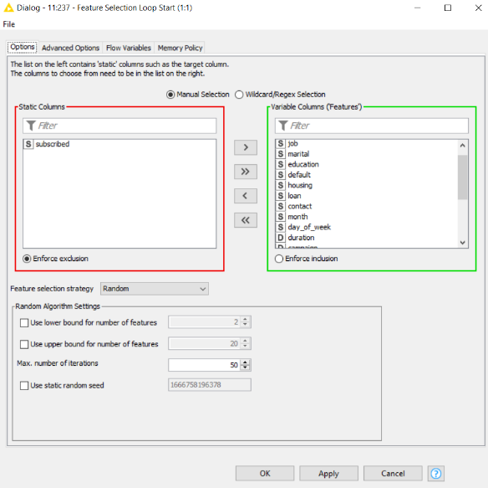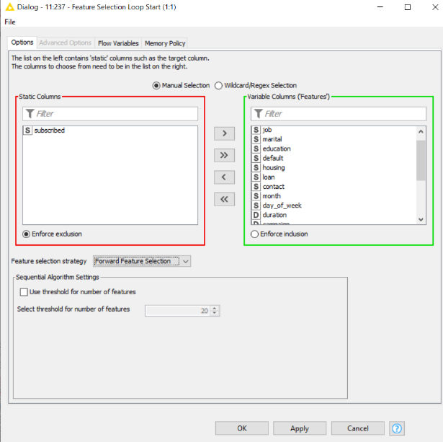

Figure 26

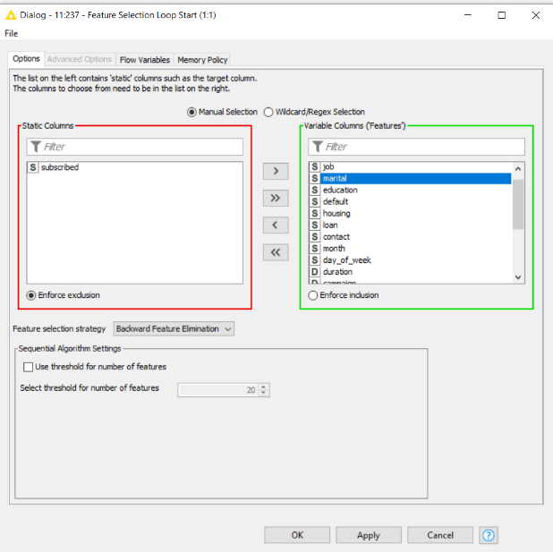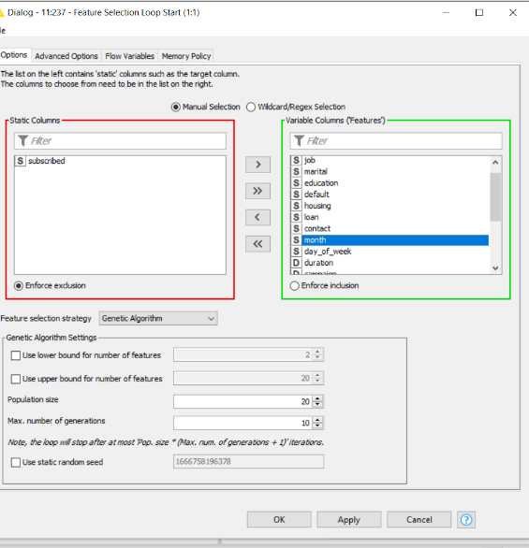

Figure27

**Feature Selection Loop End Node**

This is the end of a feature selection loop that selects features according to a feature selection strategy. It allows a selection of a flow variable. Accuracy is chosen as the flow variable. The accuracy variable value has a maximized score value because accuracy needs to be maximized. To maximize accuracy, the checkbox does not need to be clicked.

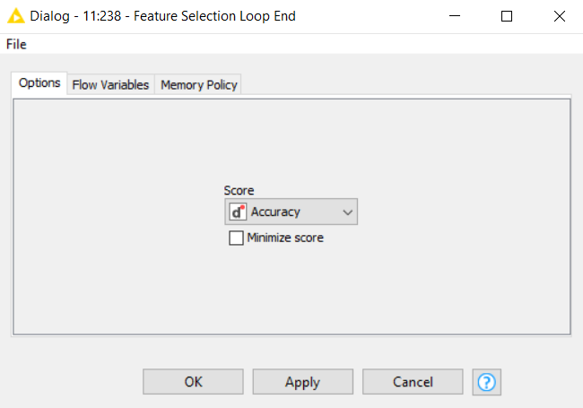

Figure28

**Feature Selection Filter Node**

The output table was customized using the columns that must be included in the feature selection loop. Select the best score which will show the best result as an output.

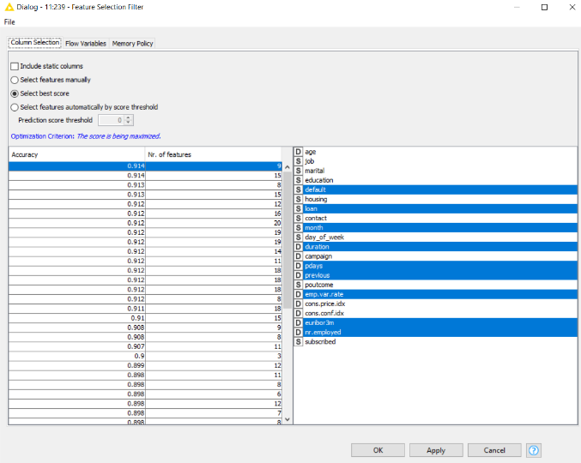Figure29

**Solving the Problem:**

A systematic approach was followed to predict the subscribed attribute value, and different methods, arrangements, and configurations of KNIME classifier nodes were tested. It is iteratively refined by cleaning and smoothing the data. To clean the data, ten classifiers were used, and six or eight pre-processing nodes were used. Feature selection filters out the columns from the dataset (Figure 26,27,28 and 29). A random method is chosen to select the feature combinations randomly.

Parameter optimization in several classifiers was used with varied settings and parameters to obtain better accuracy and f-measure. Through different parameters were tried for better results. The loop starts a parameter optimization loop. Different parameters with an interval and a step size were tried. Then, the loop closes a parameter optimization loop. The flow variable accuracy has been chosen. The accuracy ''variable score'' was maximized.

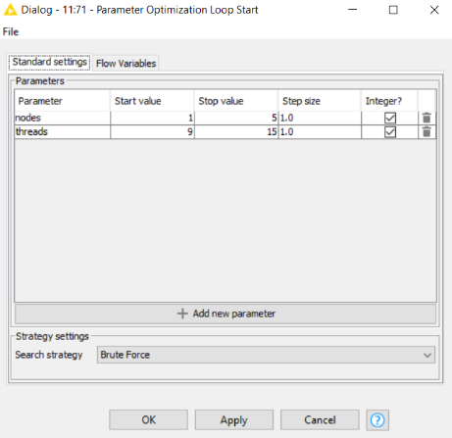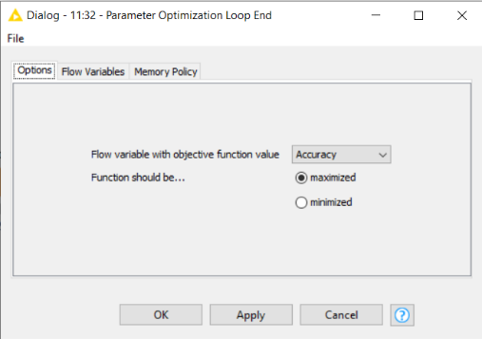Figure30

The unbalanced dataset is handled using a SMOTE node which helped the classifier to be oversampled by the minority classes. This algorithm helps to overcome the overfitting problem generated by the random oversampling of minority classes. It helped to solve the problem while building the classifiers. Moreover, it gave the best prediction of the class column.

The k-fold method and the partitioning strategy were both used to build different models. In k-fold partitioning number of validations is chosen as ten because it has a large dataset. For example, cases of 80-20 and 60-40 were tried out, but most of the classifiers came up with solutions with the 70-30 partition.

These predictions were all measured using the Scorer node, viewing the confusion matrix, analysing the accuracy and F-measure, viewing the probability distribution of the predictions using the ROC Curve and analysing the shape and the area under this curve.

**Classification Technique:**

1. **Decision Tree**

The goal is to create a model that predicts the value of a target variable. The data is predicted by using the decision tree model. The highest amount of time was spent optimizing results achieved by the Decision Tree classifier. After trying out several configurations, the decision tree could predict the best accuracy and F-measure with the help of a feature selection loop. Since the F-measure for value one is not extremely high, compared to the gradient boosted, this classifier is selected as a top second position.

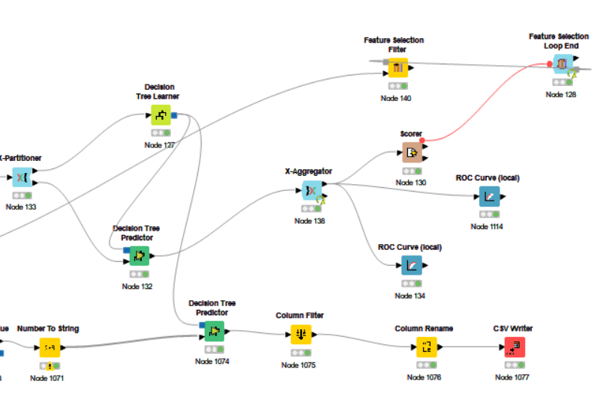

Figure31

The K-fold method is used to improve the model's quality.

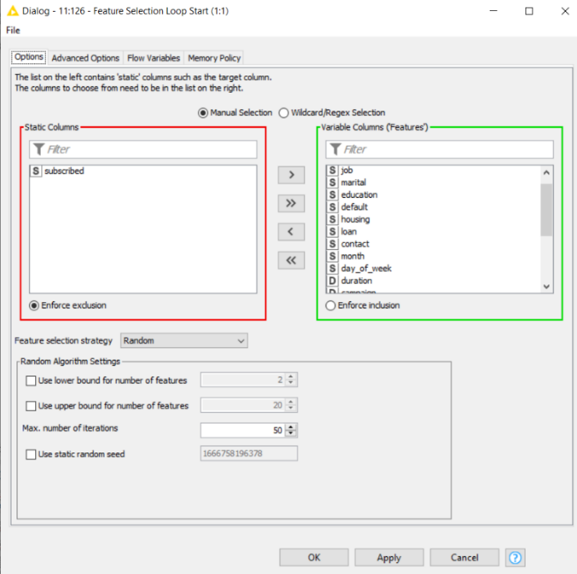

Figure32

Feature selection loop tried with a maximum number of iterations equal to 50. I have tried strategies such as forward feature selection, backward feature elimination, genetic algorithm, and random. Got the best results with the random. And included all the columns except the target attribute in the variable column to filter out the non-required column in the dataset.

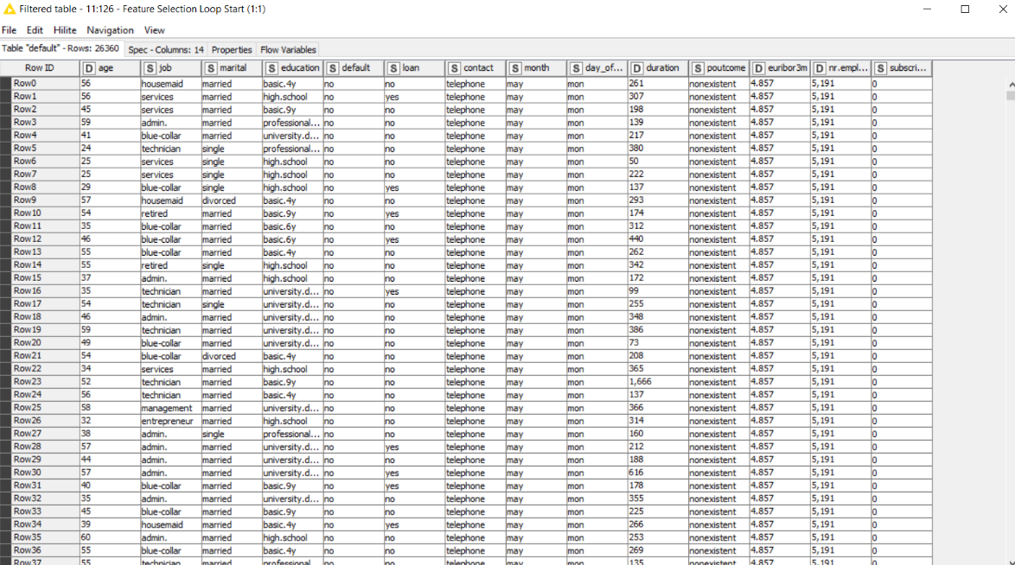

Figure33 Filtered Table

This is the filtered table, as you can see above, with columns- age, job, marital, education, default, loan, contact, month, day_of_week, duration, poutcome, Euribor, nr.employed and subscribed.

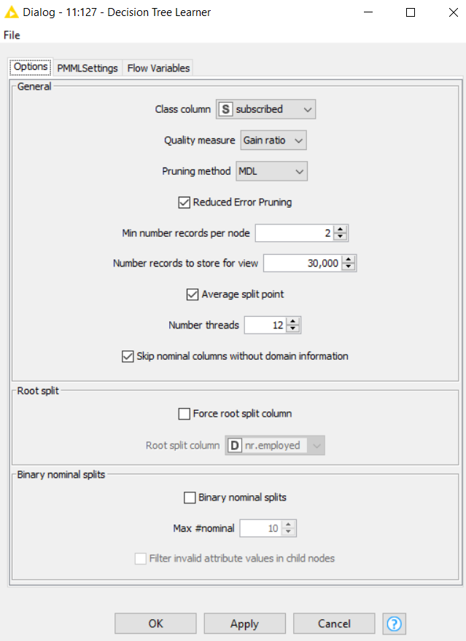

Figure34

The decision tree was tried out with different quality measure gain ratios and the Gini index. Got the best result with the gain ratio. First, I started to do the decision tree without the pruning method, but the workflow still showed the error that it contained the missing value after applying the missing node. So, for this error, the pruning method MDL has been applied to help eliminate the error. Nevertheless, we got the best results with the number of threads equal to 12 and the minimum number of records per node equal to 2.

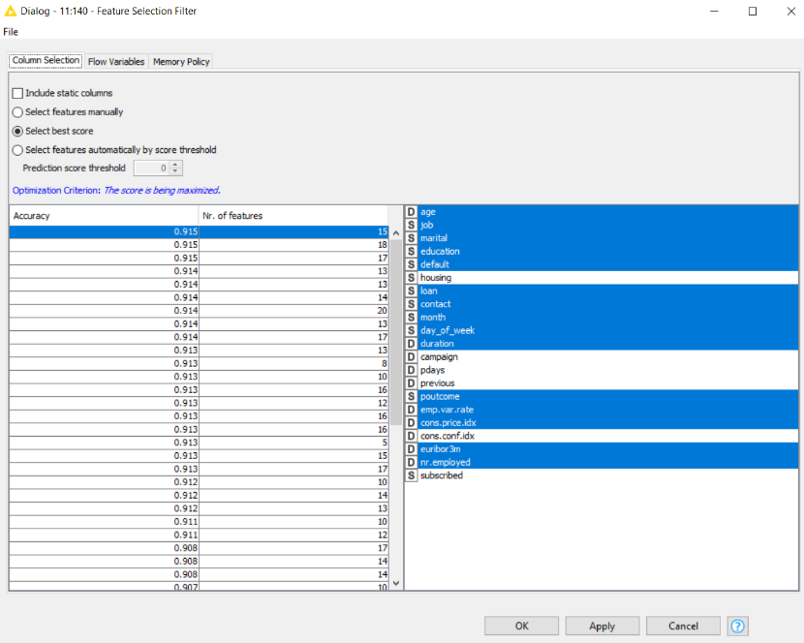

Figure35

As you can see above, this feature selection filter is based on the best score option.

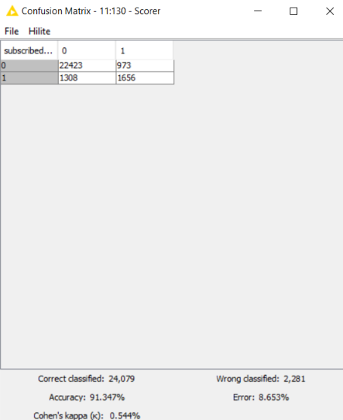

Figure36

Figure37

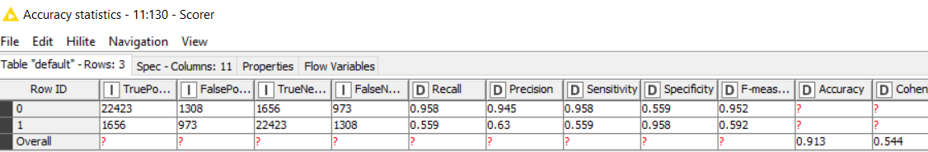

Figure38

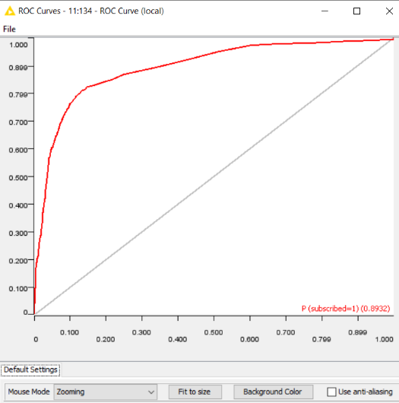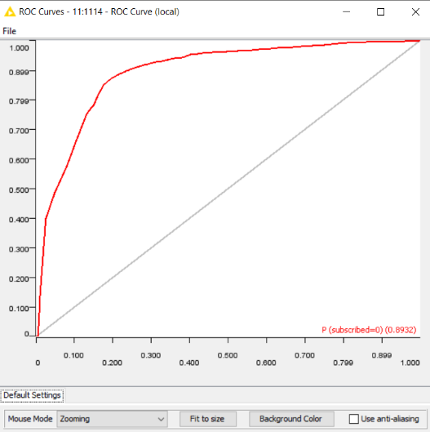

Figure39

The confusion matrix shows an accuracy of 91.347%, with a wrongly classified equal of 2,281. The accuracy statistics achieved through this are shown above. The scorer shows the f-measure of 0.952 (subscribed = 0) and 0.592 (subscribed = 1). We can also analyse the area under the ROC curve.

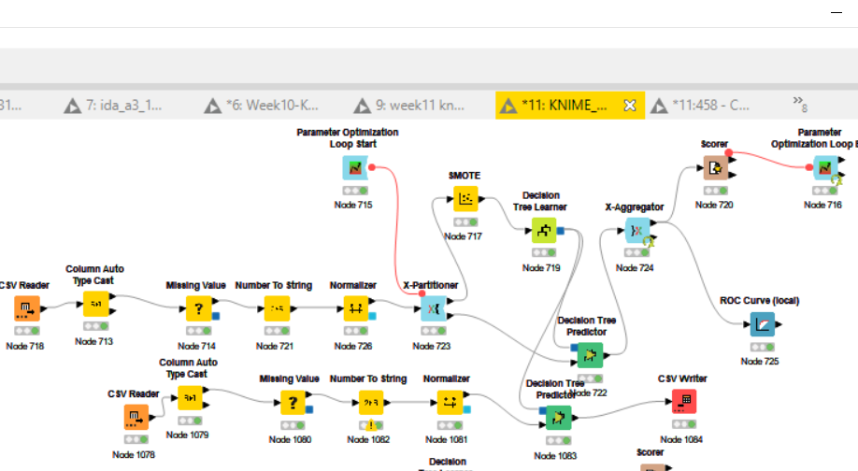

Figure40

Another decision tree was tried out with the parameter optimization, Normalizer, and SMOTE node one by one. However, it degraded the quality of the model, as you can see in the accuracy statistics (Figure 43) shown below:

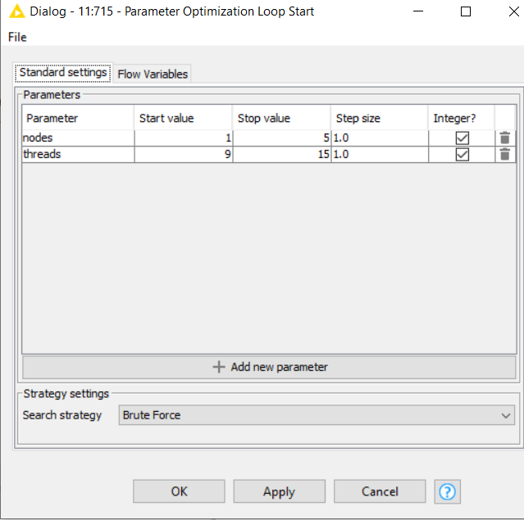

Figure41

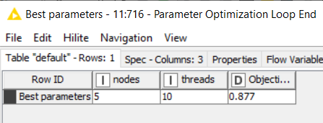

Figure42

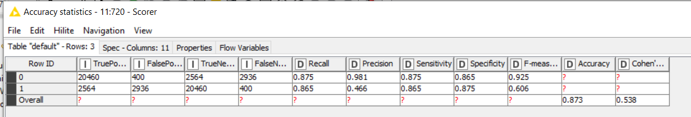

Figure43

Decision Tree works better with the feature selection.

1. **KNN (K Nearest Neighbour)**

The data is predicted through K nearest neighbour. The accuracy statistics achieved through this are shown below. We can also analyse the area under the ROC curve. Since the F-measure for value one is not relatively high, it is suggested that this classifier be disregarded compared to the others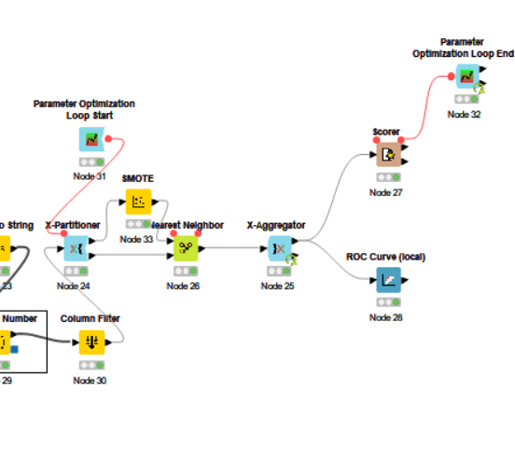

Figure44

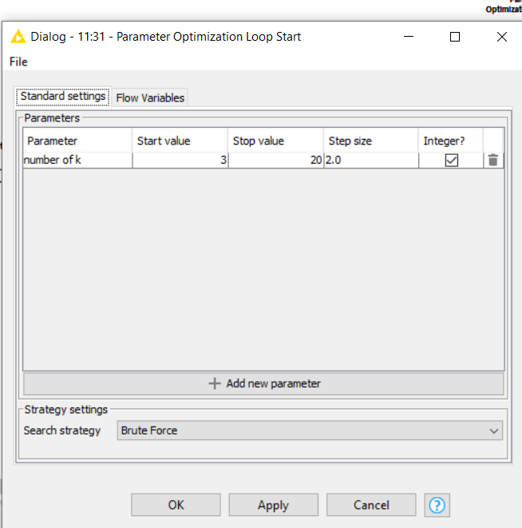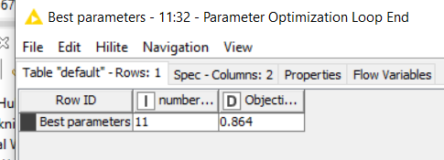

Figure45 Figure46

Parameter optimization loop and k-fold method have been used in the workflow with the smote node. The k-fold method is used to increase the quality of the model. Parameter optimization is used to try several parameters to find the best one. The best parameter is 11. Smote node helped to get the best f-measure and accuracy.

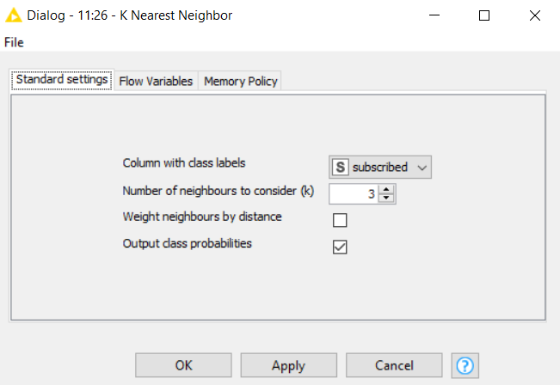

Figure47 K-nearest settings

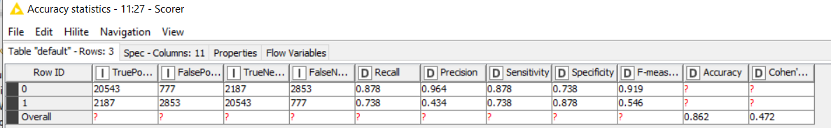

Figure48

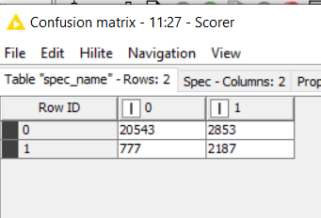

Figure49

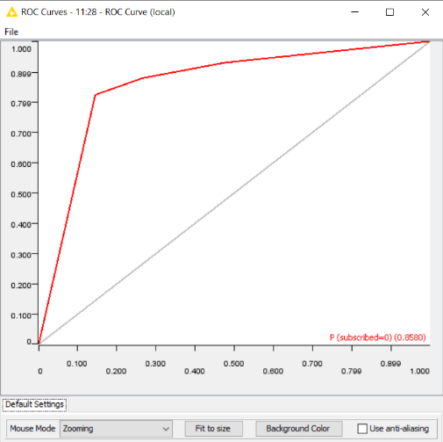 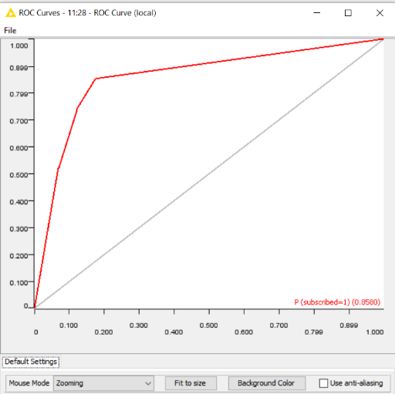

Figure50

The figures show that it has an f-measure of 0.919 and 0.546 for the majority and minority classes. The confusion matrix shows an accuracy of 86.229% with, wrongly classified as 3,630. We can also analyse the area under the ROC curve. Normalizer is not used in this model because it showed less accuracy after being applied.

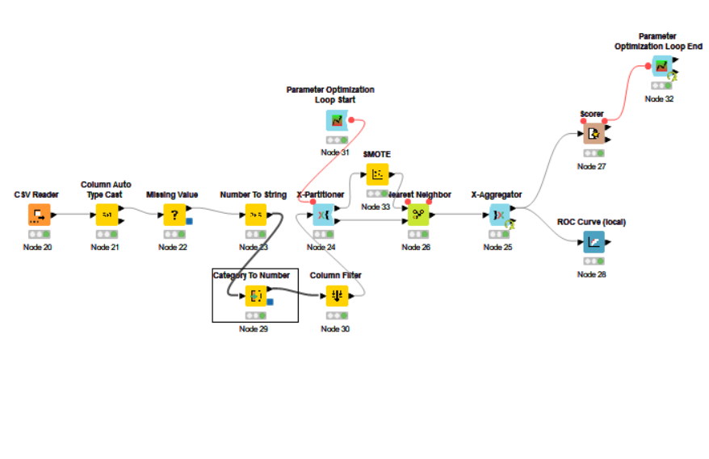

Figure51 – This the best K- Nearest model to consider.

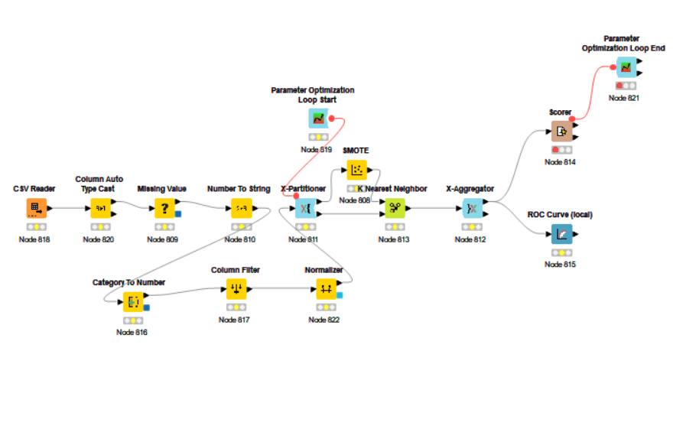

Figure52 – Another model tried out Using Normalizer (This model is not considered).

1. **Random Forest**

The goal is to create a model that predicts the value of a target variable. The data is predicted by using the random forest model. An accuracy of approximately 90.451% with 2517 wrongly classified values in the validation set is obtained. Several split criteria were performed. However, the random forest's best result was with the Gini index and tree depth change to 15. Random forest got the best result when applying SMOTE to oversample the minority classes. Accuracy was low when a normalizer and column filter was applied to the model. The k-fold method has been used for the quality of the model. This model is the top 3rd for the prediction of the target attribute.

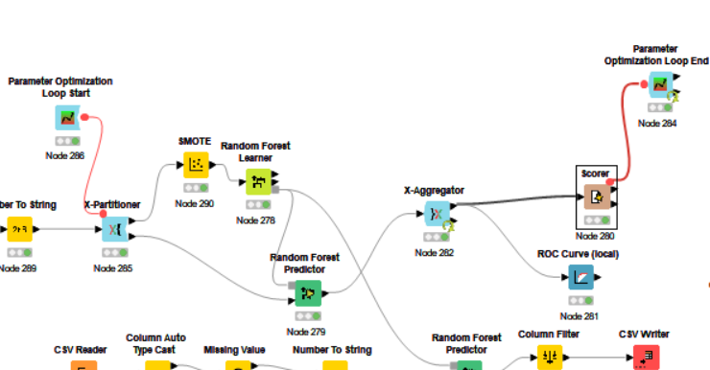

Figure53

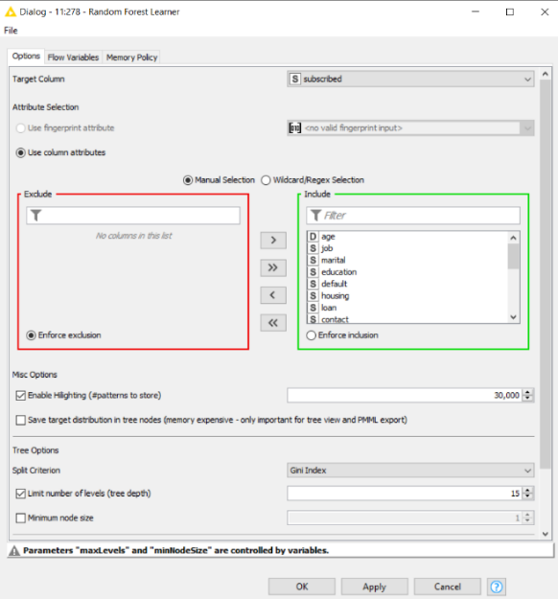

Figure54

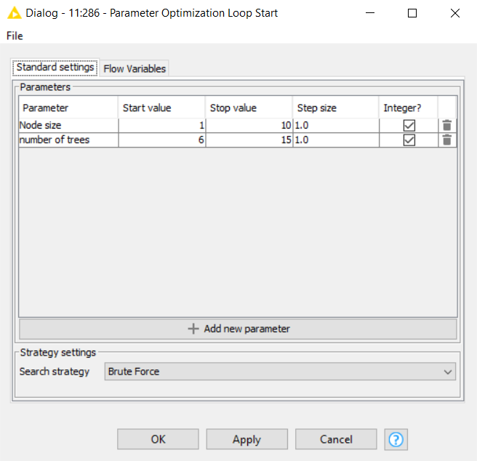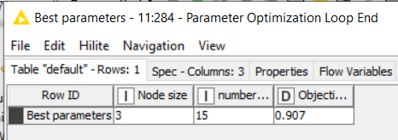

Figure55 Figure56

The parameter optimization loop has been tried out to get better results. The two parameters are Node size and the Number of trees. The best parameter is Node size = 3 and Number of trees = 15.

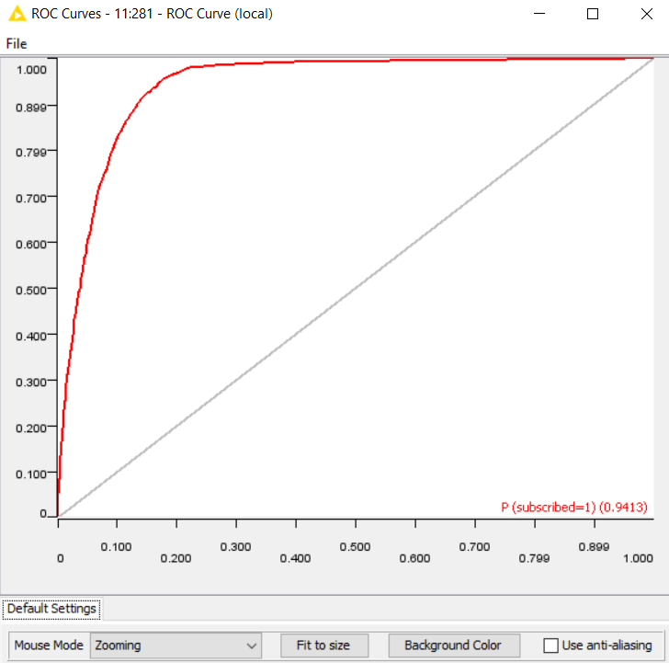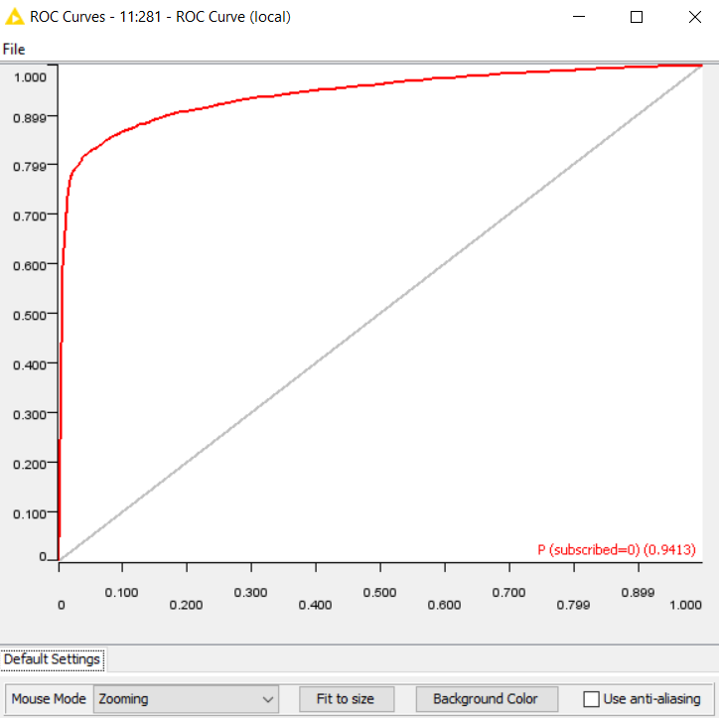

Figure57

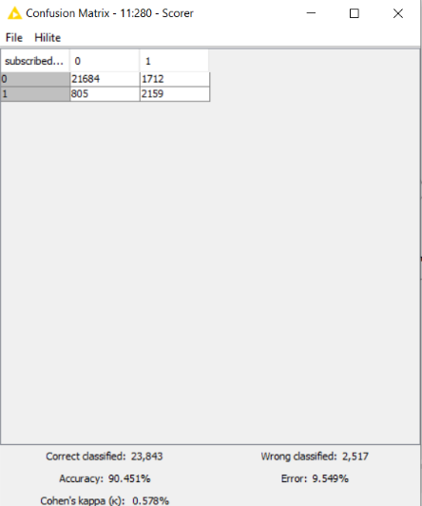

Figure58

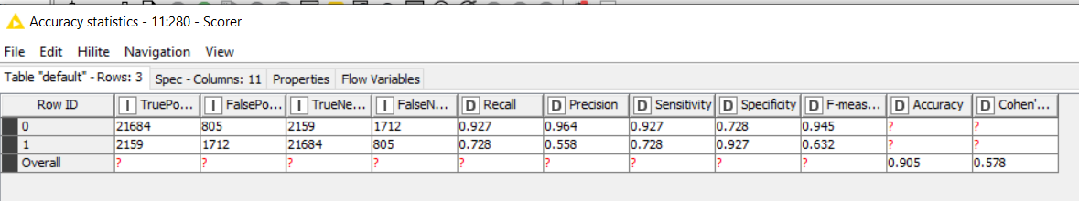

Figure59

The above figures show an f-measure of 0.632 and 0.945 for the majority and minority classes. We can also analyse the area under the ROC curve. The ROC curve:

P (subscribed = 1) and P (subscribed = 0) is 0.9413

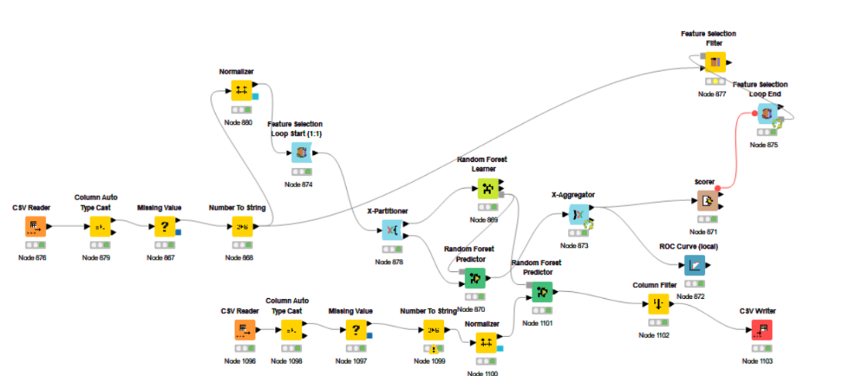

Figure60

Another Random Forest model is tried out with the normalizer and the feature selection method.

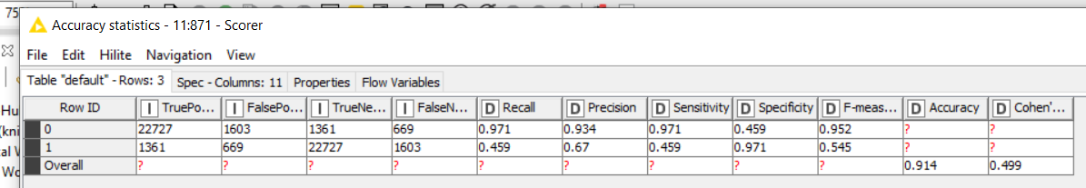

Figure61

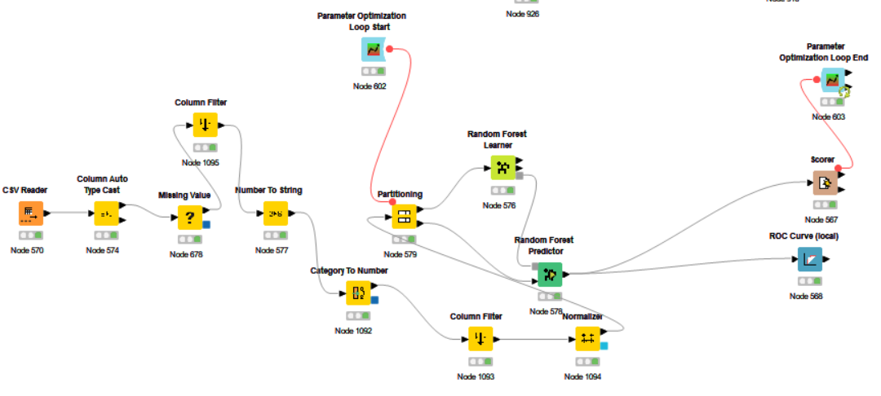

Figure62

Another Random Forest model was tried with the normalizer.

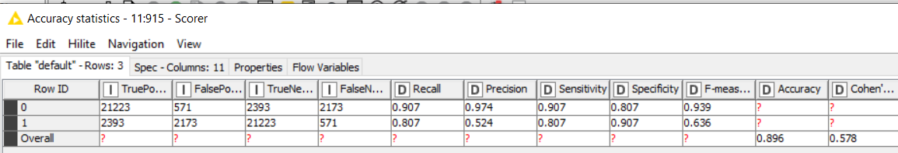

Figure63

When applying a normalizer, the column filter according to the split column and feature selection node shows less accuracy and f-measure. You can see the figure above. The feature selection loop was tried out on the model with the Normalizer and without the Normalizer, and the model showed less accuracy/f-measure. Filter out column through the rank correlation, but the negative correlation filtration did not work as it showed low accuracy.

1. **Tree Ensemble**

The goal is to create a model that predicts the value of a target variable. The data is predicted by using the Tree ensemble model. After trying out several configurations, the decision tree could predict the best accuracy and F-measure with the help of SMOTE node. An accuracy of approximately 90.486% with 2508 wrongly classified values in the validation set is obtained.

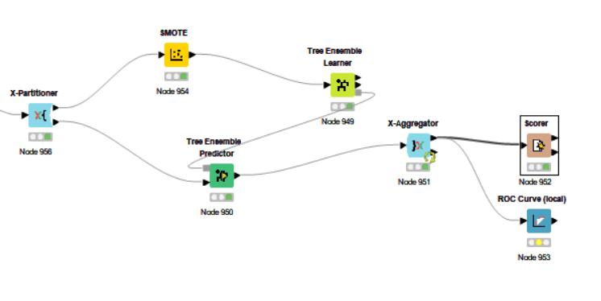

Figure64

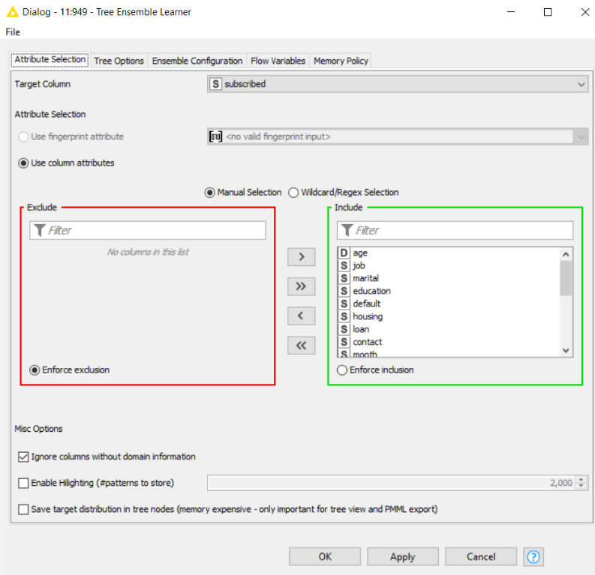

Figure65

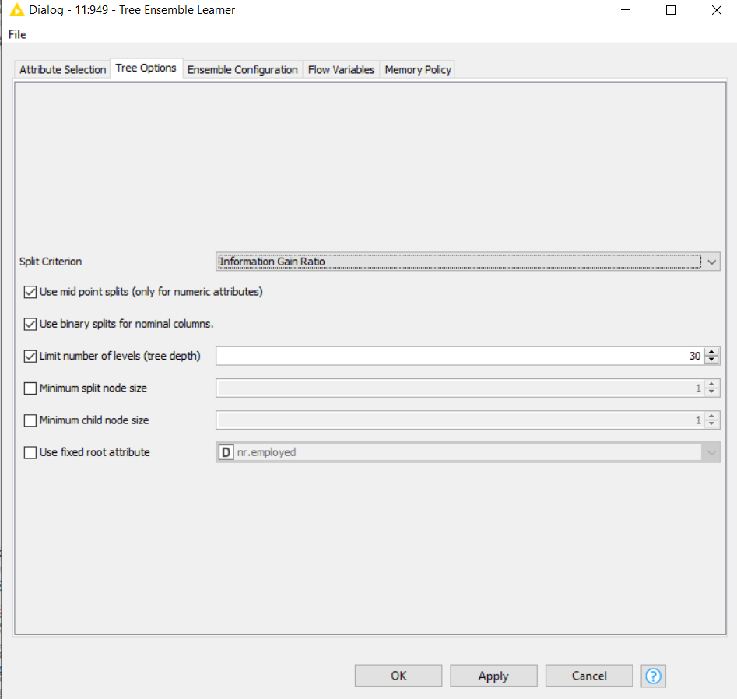

Figure66

Examine with different split criteria. The best split criteria were Information Gain Ratio. The settings of the tree depth have been changed to 30. The number of levels of tree depth is 30.

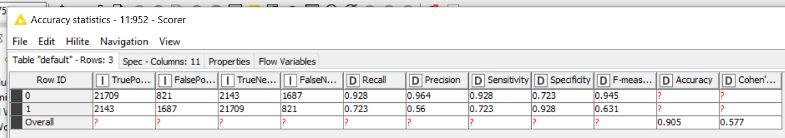

Figure67

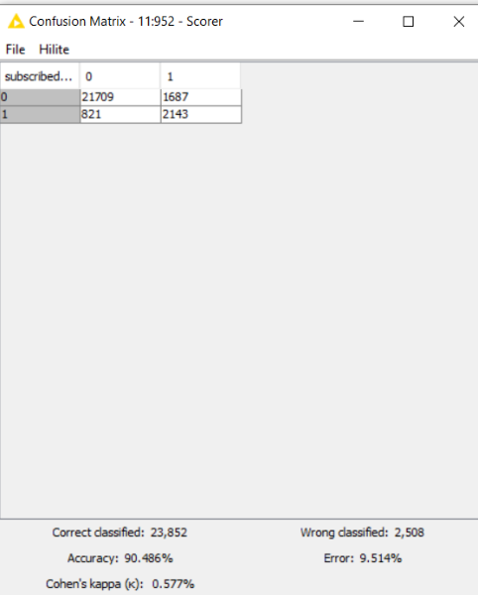

Figure68

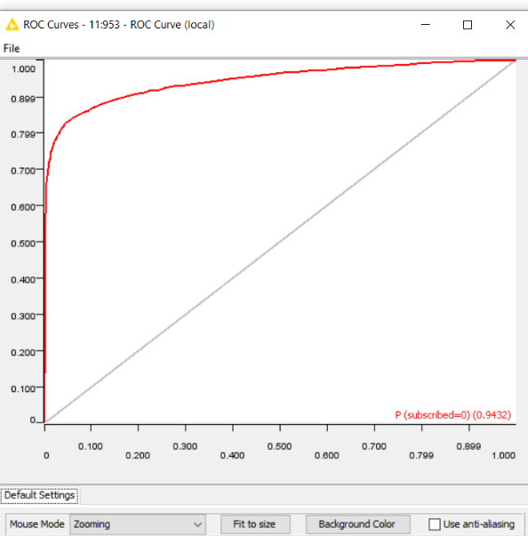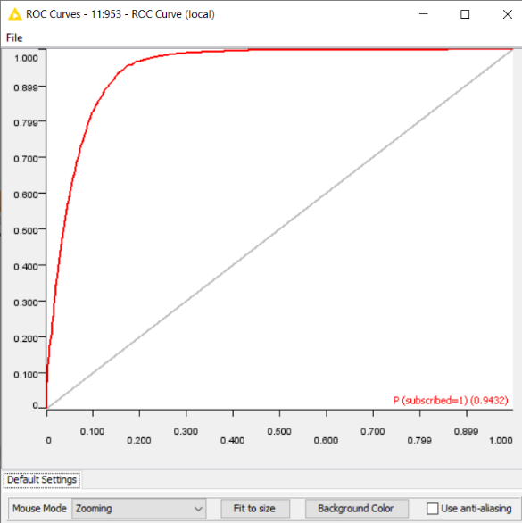

Figure69

From the above figures, we conclude that it has an f-measure of 0.945 and 0.631 for the majority and minority classes. ROC curve: P (subscribed = 0) and P (subscribed = 1) is 0.9432.

1. **Gradient Boosted**

The goal is to create a model that predicts the value of a target variable. The data is predicted by using the Gradient Boosted model. The highest amount of time was spent optimizing results achieved by the Gradient Boosted Model. After trying out several configurations, the gradient Boosted could predict the best accuracy and F-measure with the help of a feature selection loop. Since the F-measure for value is remarkably high compared to the other classifiers, this model is selected as the best model.

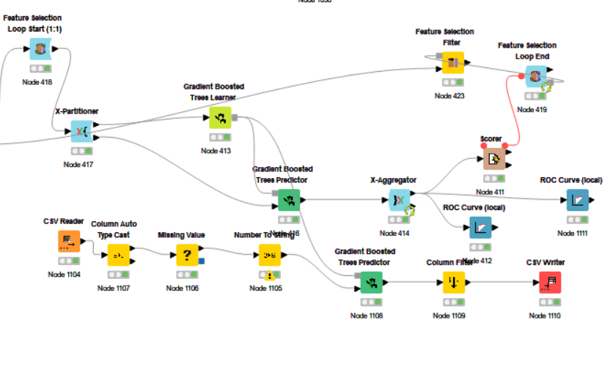Figure67

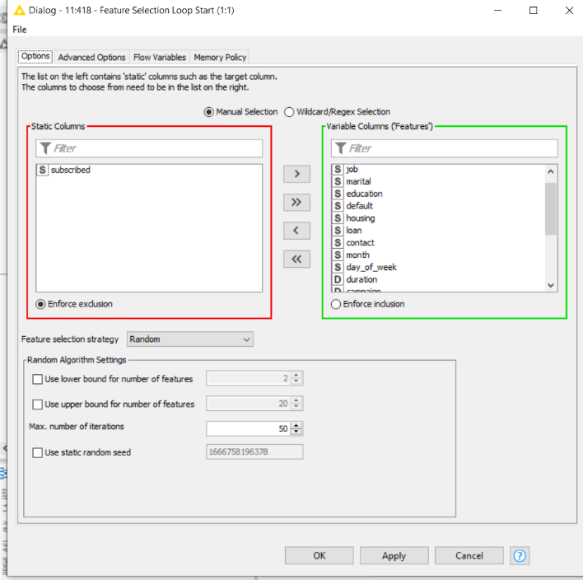Figure68

Feature selection loop tried with the maximum number of iterations equal to 50. I have tried strategies such as forward feature selection, backward feature elimination, genetic algorithm, and random. Got the best results with the random. And included all the columns except the target attribute in the variable column to filter out the non-required column in the dataset.

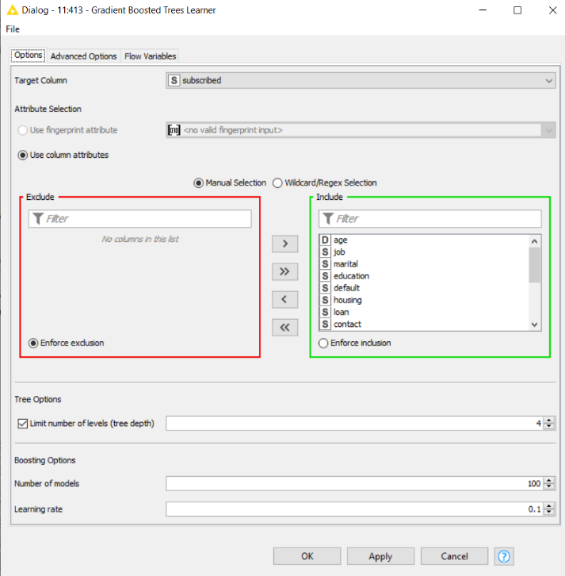Figure69

To boost the model boosting options number of models 100 was chosen, and tree depth equals four was set as default.

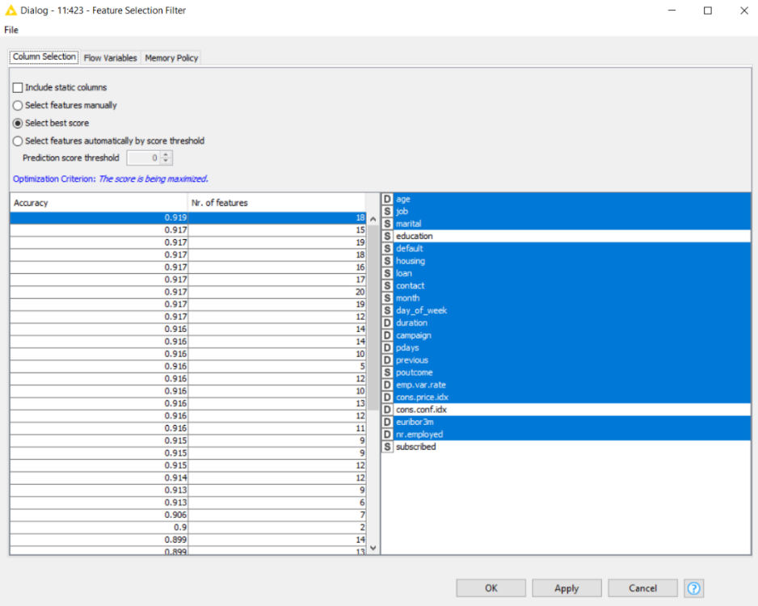Figure70

As you can see above, this feature selection filter is based on the best score option.

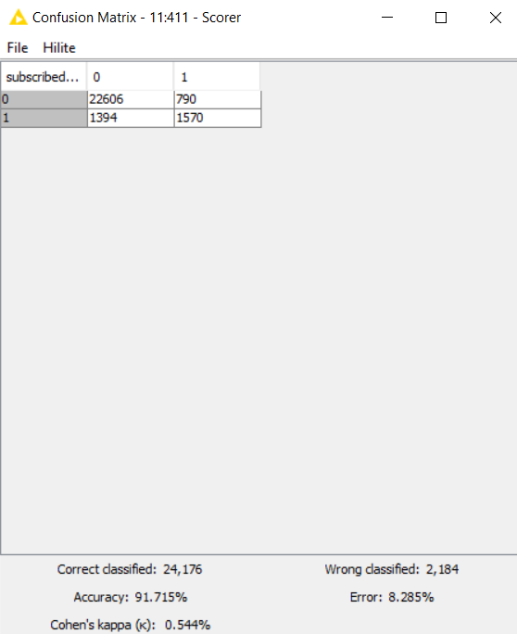Figure71

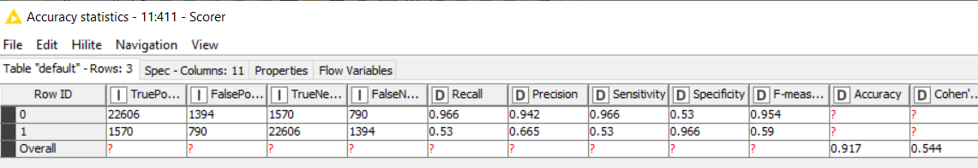

Figure72

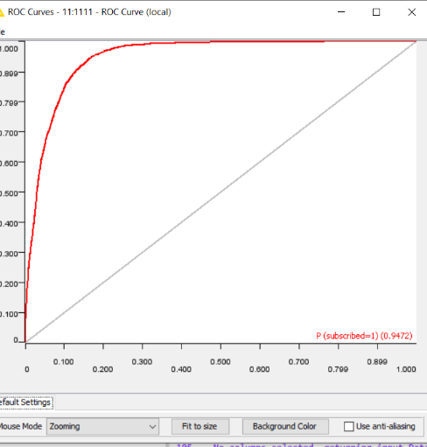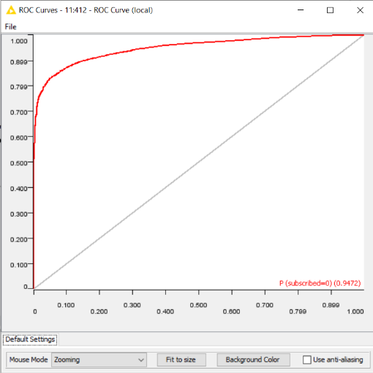

Figure73

From the above figures we conclude that it has a f-measure of 0.945 and 0.59 of the majority and minority class. ROC curve: P (subscribed = 0) and P (subscribed = 1) is 0.9472. It has a accuracy of 91.715% with wrongly classified as 2,184.

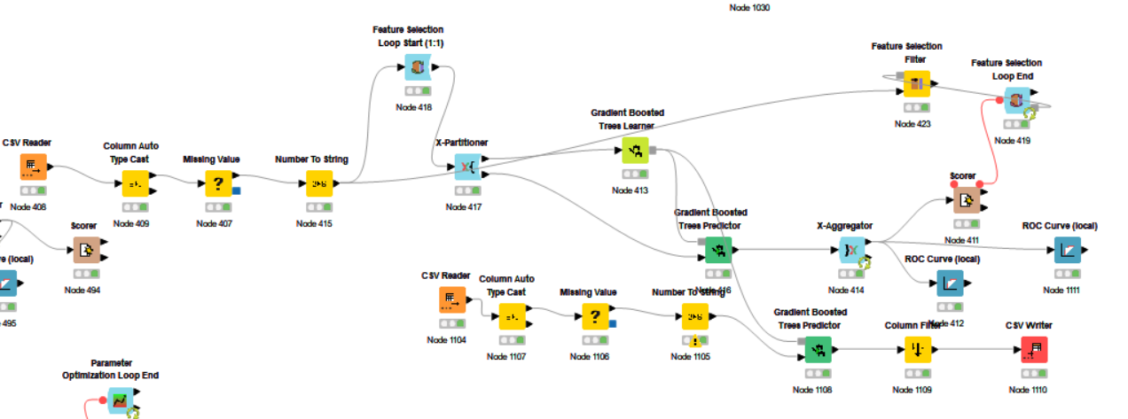

Figure 74 - Gradient boosted model to consider

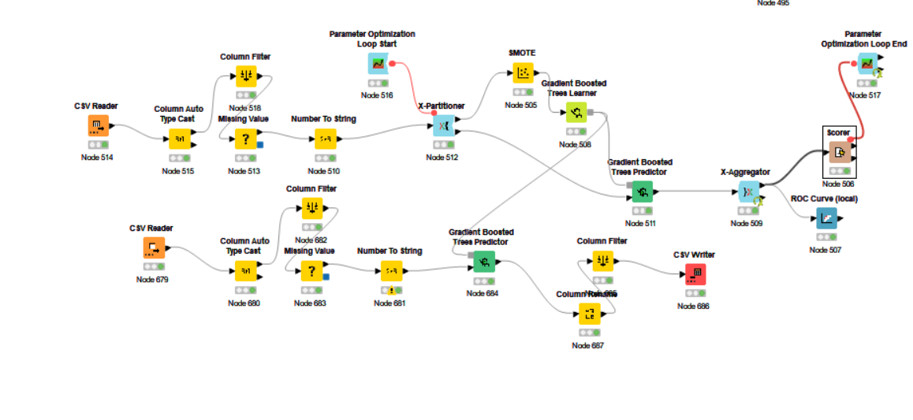

Figure75 - Another gradient boosted model using parameter optimization, SMOTE and column filter using split column of the random forest. (not to consider)

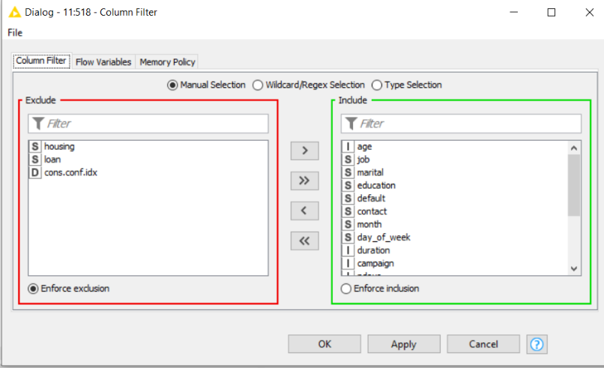

Figure76

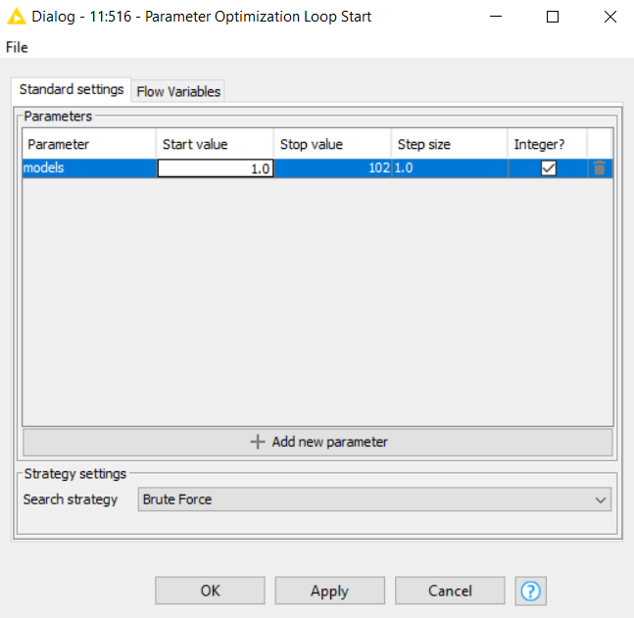

Figure77

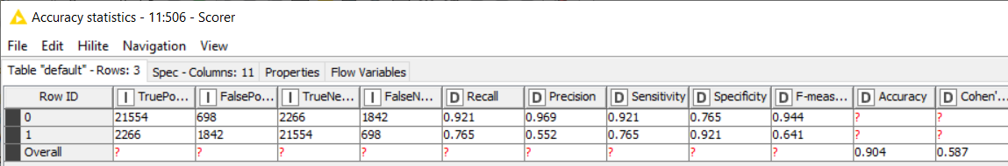

Figure78 - Got the less accuracy as compared to the feature selection gradient boost. Feature selection work best on the gradient boosted.

1. **Neural Network**

The goal is to create a model that predicts the value of a target variable. Then, the data is predicted by using the Neural Network model. After trying out several configurations, the neural network could predict the best accuracy and F-measure with the help of a parameter optimization loop.

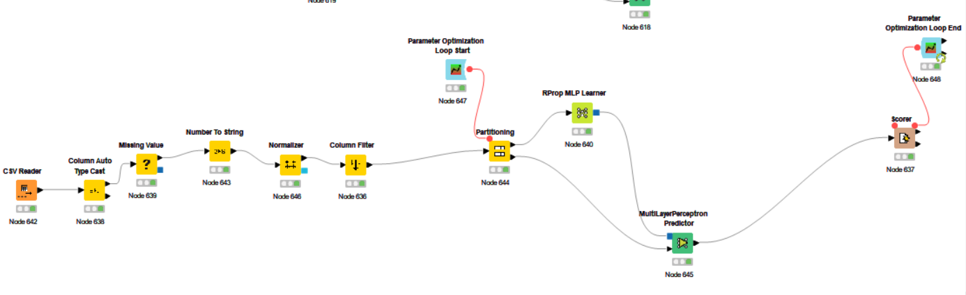

Figure79

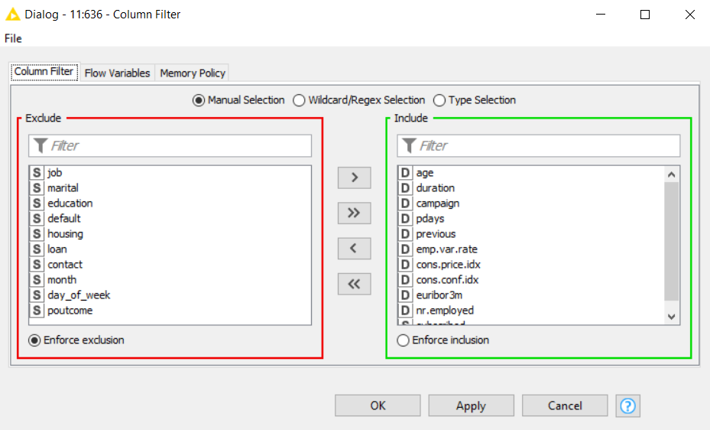

Figure80

Column filter excludes the string columns and includes all the double columns because the neural network can only take double values. A normalizer is used to change the values and make them in the range of 0.0 and 1.0. String subscribed is still included in the column filter because it is the class attribute.

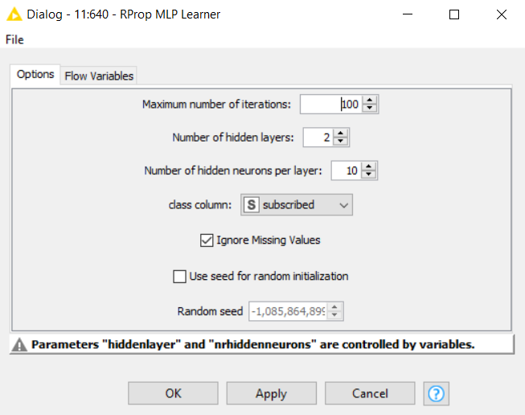

Figure81

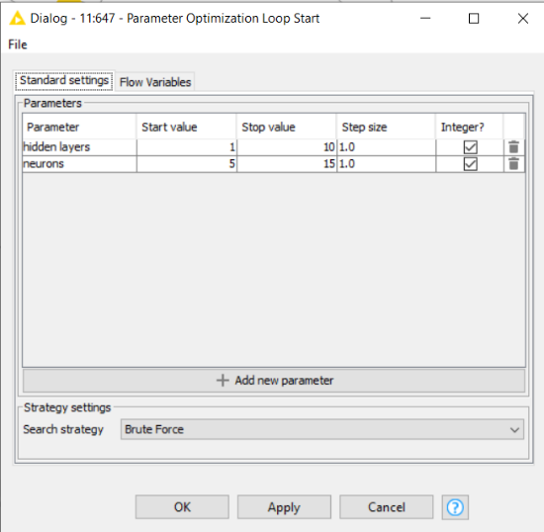 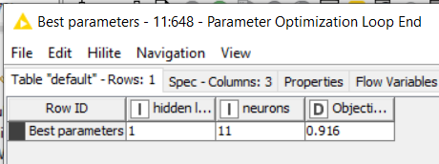

Figure82 Figure83

Parameter optimization loops have been used in the workflow. Parameter optimization is used to try out several parameters in one go to find out the best one. For example, the best parameter of hidden layers and neurons are 1 and 11.

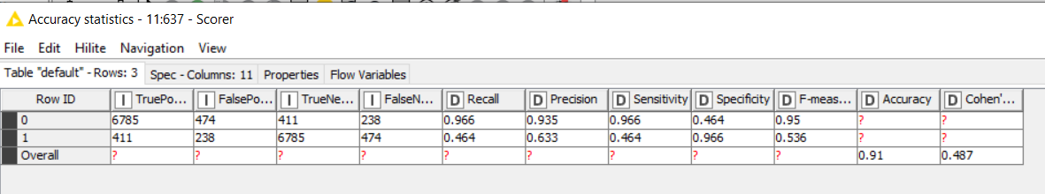

Figure84

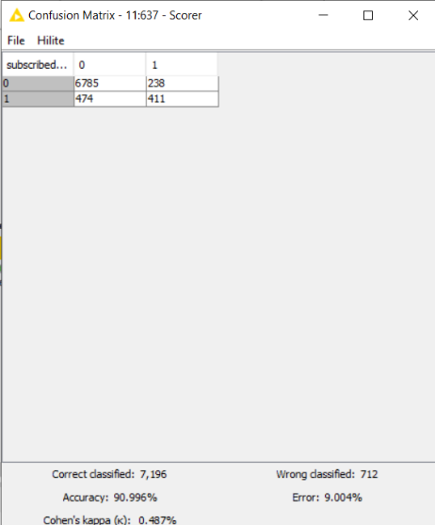

Figure85

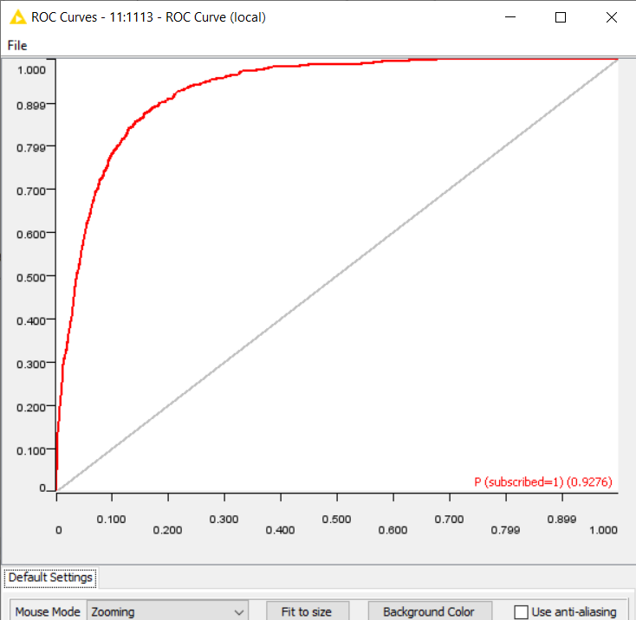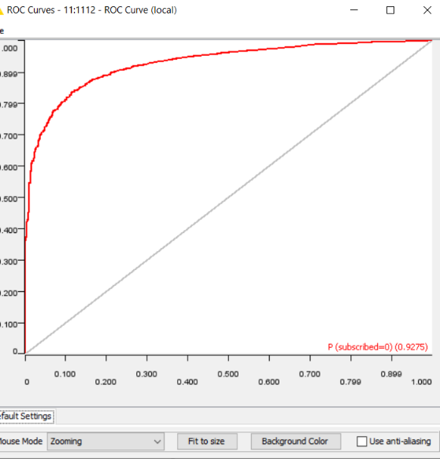

Figure86

From the above figures, we conclude that it has an f-measure of 0.95 and 0.536 for the majority and minority classes. ROC curve: P (subscribed = 0) and P (subscribed = 1) is 0.9476. It has an accuracy of 90.996% with, wrongly classified as 7,196.

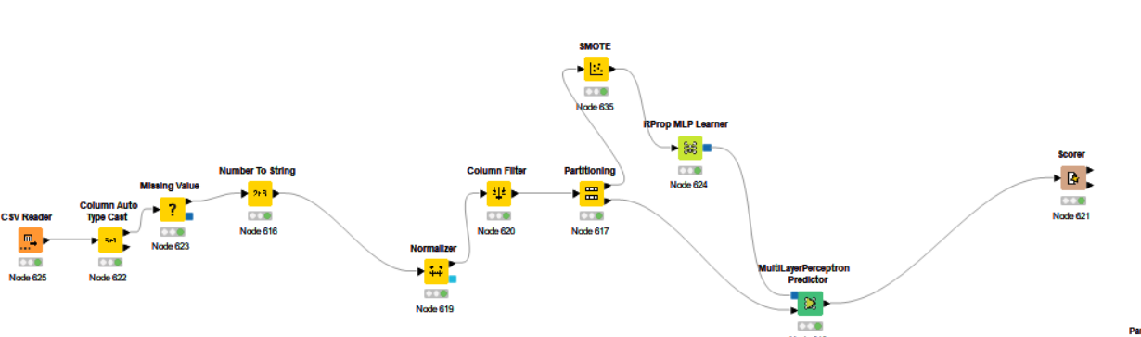

Figure87- Another neural network was tried out with the smote node. (not to consider)

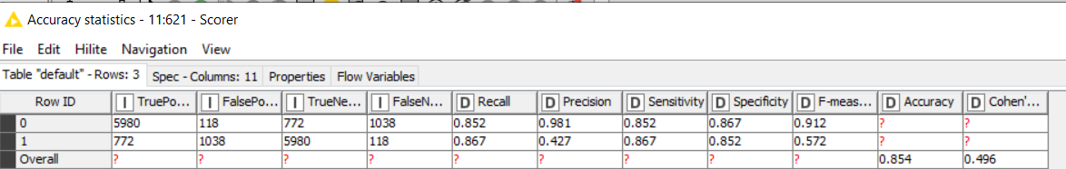

Figure88

Smote node did not give the best f-measure and accuracy in neural network.

1. **SVM (Support Vector Machine)**

The goal is to create a model that predicts the value of a target variable. The data is predicted by using the support vector machine. After trying out several configurations, the support vector machine could predict the best accuracy and F-measure with the help of a normalizer and column filter. However, this classifier node took an extremely long time to run. The accuracy statistics and the configurations are shown below.

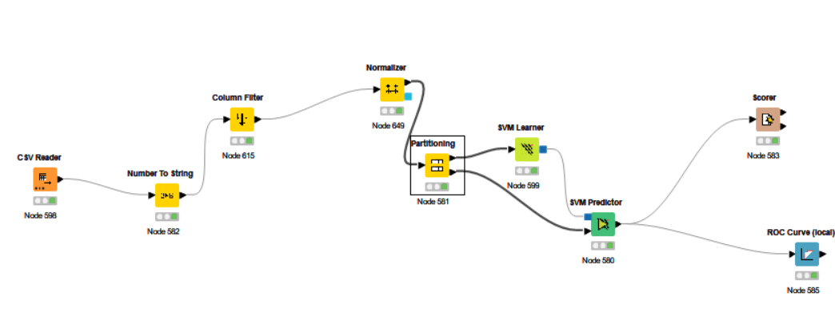

Figure89

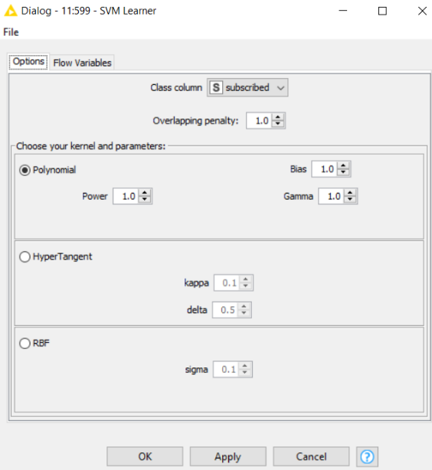

Figure90 -Tried with different kernel such as polynomial, Hyper Tangent and RBF. Polynomial showed the best results.

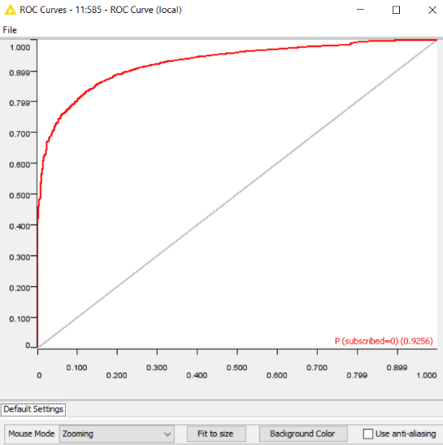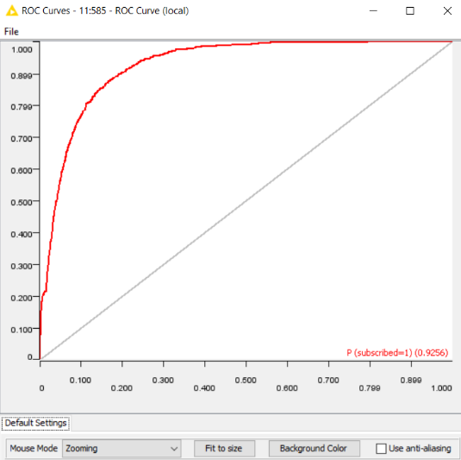

Figure91

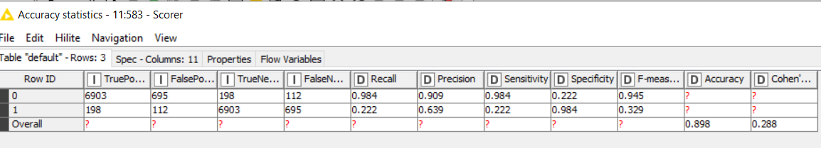

Figure92

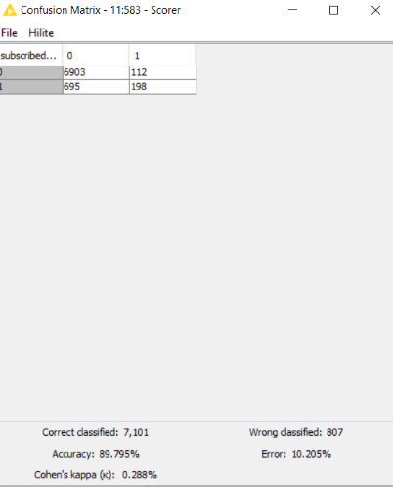

Figure93

From the above figures, we conclude that it has an f-measure of 0.945 and 0.329 for the majority and minority classes. ROC curve: P (subscribed = 0) and P (subscribed = 1) is 0.9256. It has an accuracy of 89.795% with, wrongly classified as 807.

1. **Probabilistic Neural Network**

The goal is to create a model that predicts the value of a target variable. The data is predicted by using the Probabilistic Neural Network model. After trying out several configurations, the neural network could predict accuracy and F-measure.

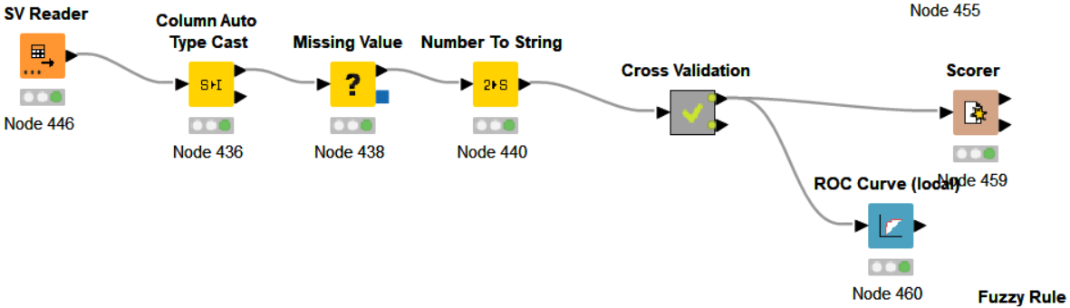

Figure94

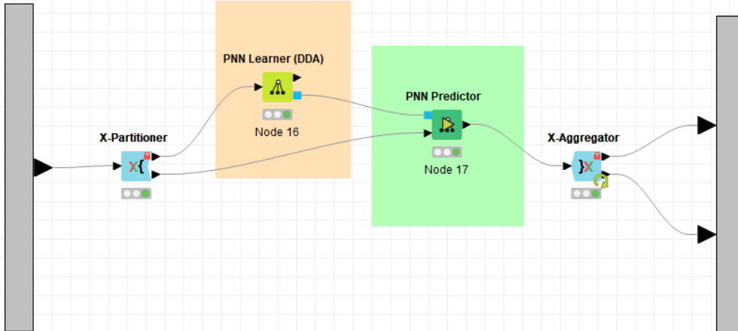

Figure95

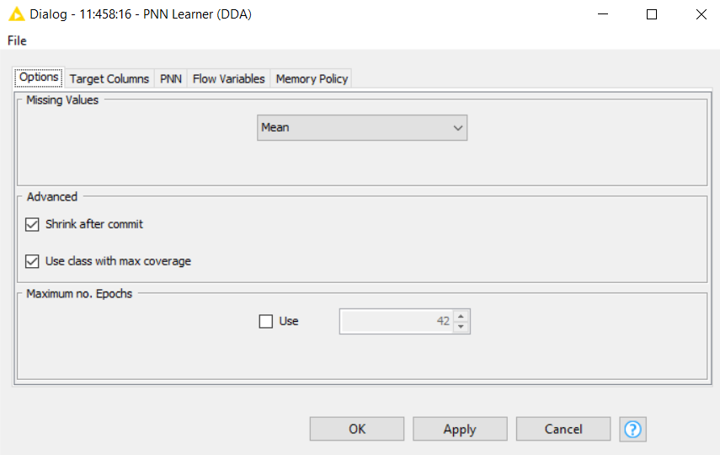

Figure96

K-fold method is used to improve the quality of the model and missing values were replaced by the mean value.

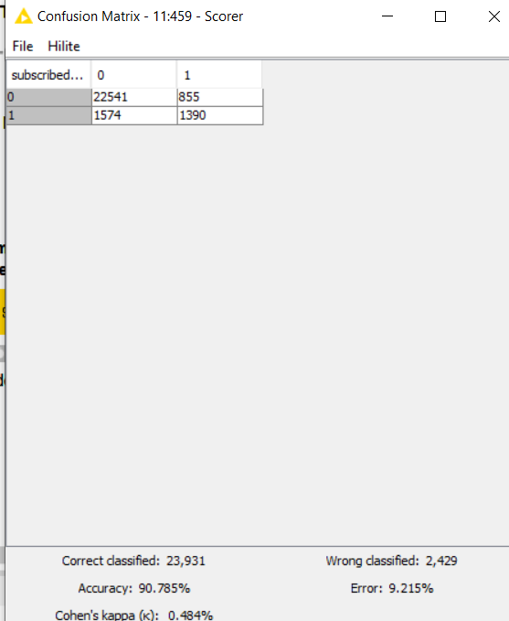

Figure97

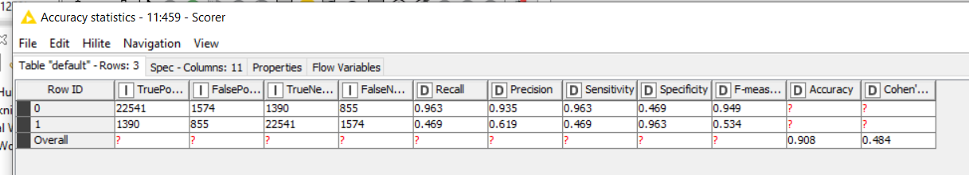

Figure98

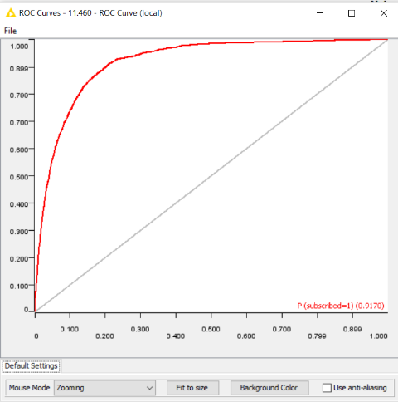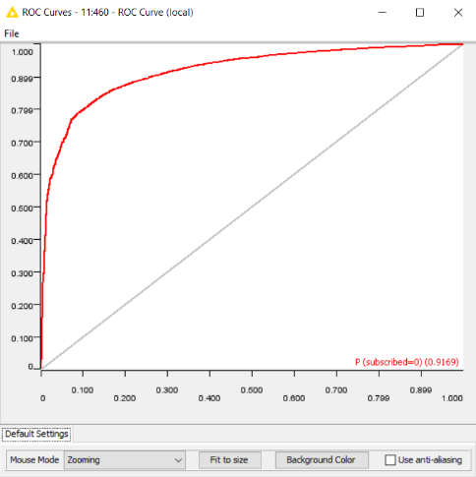

Figure99

From the above figures, we conclude that it has an f-measure of 0.949 and 0.534 for the majority and minority classes. ROC curve: P (subscribed = 0) and P (subscribed = 1) are 0.9169 and 0.9170. It has an accuracy of 90.785% with, wrongly classified as 2429.

**9. Naive Bays**

Comparatively, this was the worst classifier of the lot. This would mean the classifier would not do better than random guessing on the provided dataset.

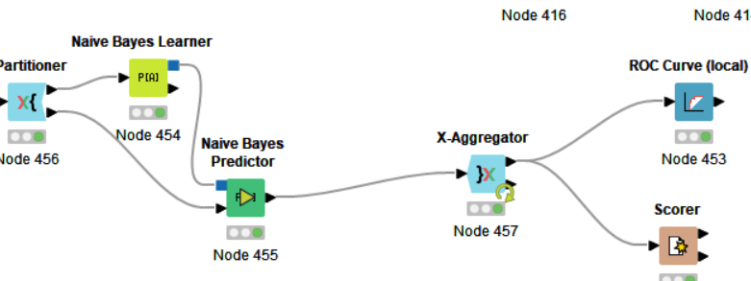

Figure100

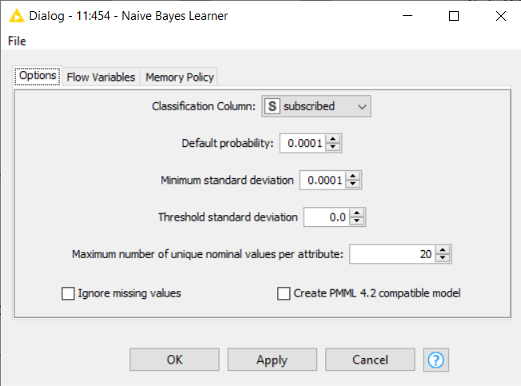

Figure101

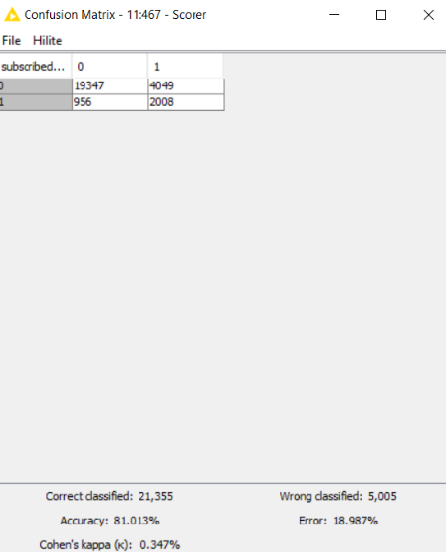

Figure102

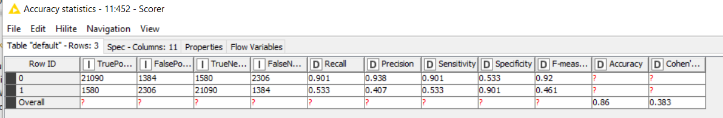

Figure103

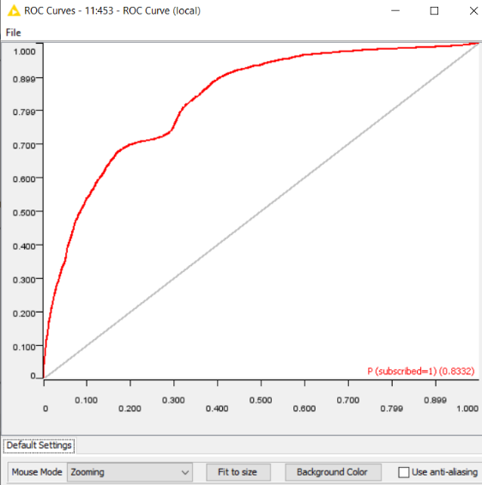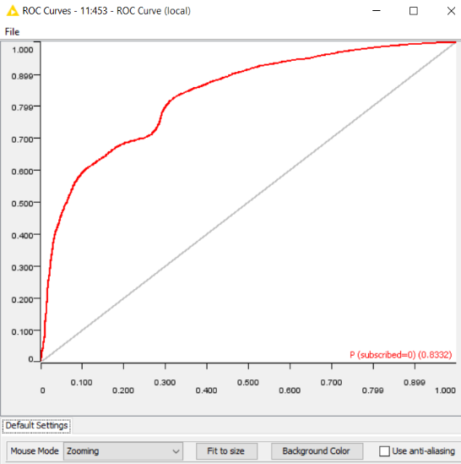

Figure104

From the above figures, we conclude that it has an f-measure of 0.92 and 0.461 for the majority and minority classes. ROC curve: P (subscribed = 0) and P (subscribed = 1) is 0.8332. It has an accuracy of 81.013% with, wrongly classified as 5,005.

**10.** **Fuzzy Rule**

This classifier produced satisfactory accuracy and could predict the subscribed relatively correctly. The configurations and results obtained are shown below. Figu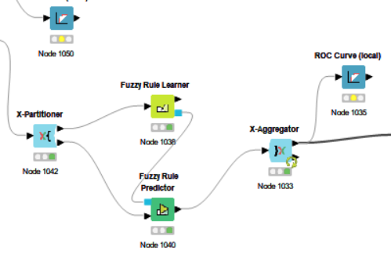

Figure105

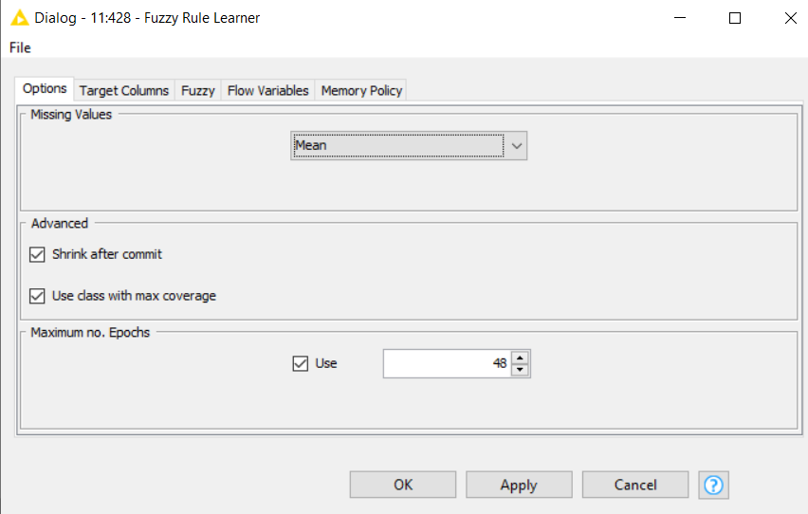

Figure106 - Use the maximum number of epochs and replaced missing value with the mean value.

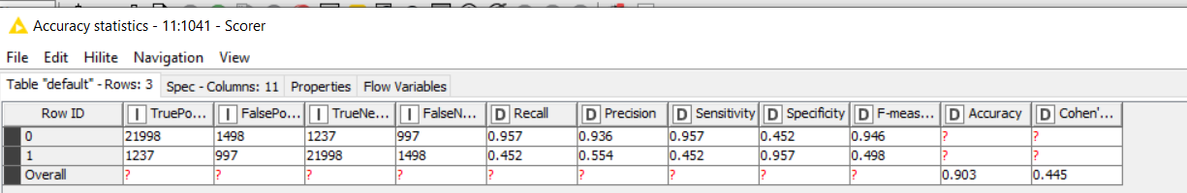

Figure107

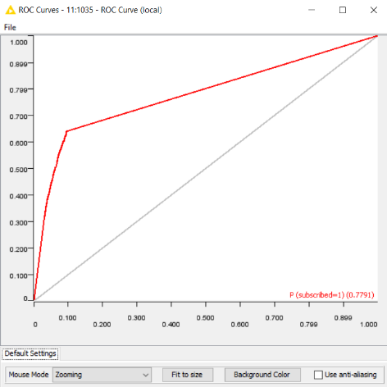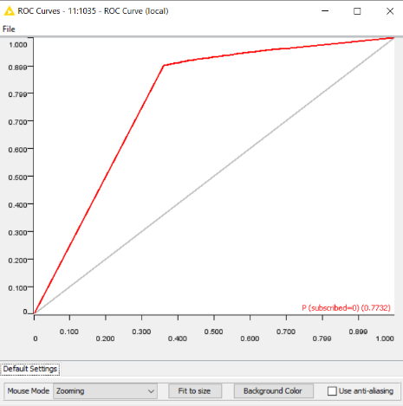

Figure108

From the above figures, we conclude that it has an f-measure of 0.946 and 0.498 for the majority and minority classes. ROC curve: P (subscribed = 0) and P (subscribed = 1) are 0.7791 and 0.7732. It has an accuracy of 0.903.

**Best Classifier**

**Gradient boosted Tree Model**

The accuracy obtained on the submission on Kaggle is 0.92412. We combine many weak learners into one strong learner in gradient-boosting decision trees. Individual decision trees are weak learners here. Throughout the process, each tree attempts to minimize the error of the previous tree. Because of this sequential connection, boosting algorithms are simultaneously slow to learn but highly accurate. Even though gradient boost, decision tree and random forest gained close results, the gradient boost classifier is identified as the best classifier based on F-measures and AUC curve analyses. The gradient boost classifier solves the issue of predicting the subscribed column attribute.

Accuracy independently cannot determine the best classifier, as the F-measure for each required value for the set should be high enough to ensure minimal bias. The gradient-boosted feature changed to a random feature, and depth equals Four. Gradient boost speeds up the classification process since the data we are looking at is categorical. Furthermore, gradient boost is preferred over decision trees because the decision tree classifier shows signs of overfitting that cannot be accounted for. Feature selection played a very important role to give the best accuracy possible.This is achieved over 90% by the gradient boost classifier. In addition, the area under the ROC curve had the most remarkable accuracy in predicting 0 and 1.

Several parameters, several classifiers, and numerous configurations of each justified gradient boost are to be chosen as the best classifier for this dataset, as we know that gradient boost gave the best accuracy.

DT -



KNN -



RF -



Tree Ensemble -



Gradient Boosted -



Neural Network -



SVM -



Probabilistic Neural Network -



Naïve Bayes -



Fuzzy Rule -



**Kaggle submission**

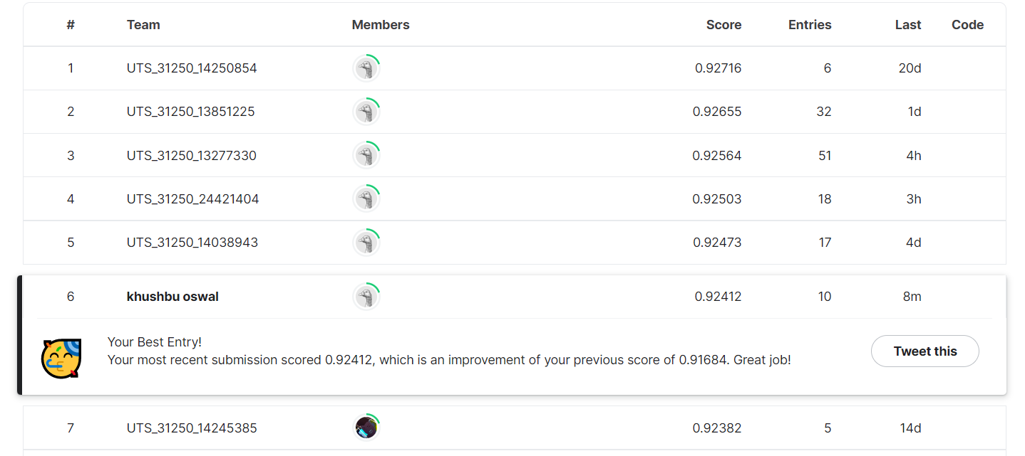

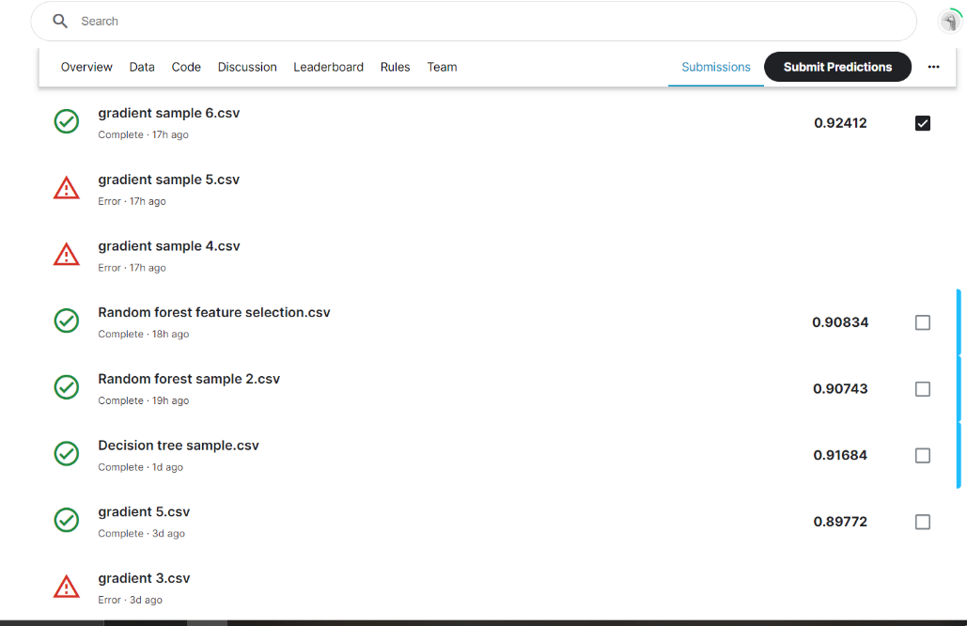

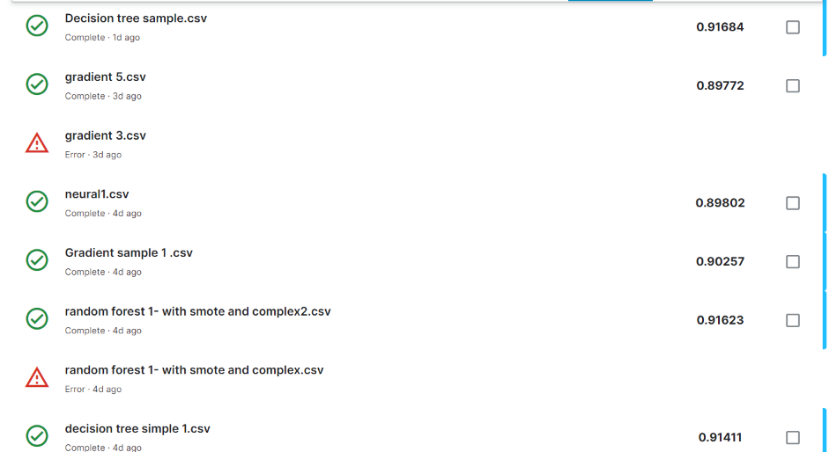

Kaggle assesses the performance of the classifier and provides the result. It was submitted multiple times for different types of models.

**Appendix**

